# Chapter-1-Introduction

In the present situation people has become very modern and technology-dependent. They want fast and easy method for communication as well as in working platforms. They don’t want to waste their valuable time in unnecessary things like standing on queue for a simple work. It is like wasting time for them. They want something which they can access from their home by using their mobiles phones, computers or by using internet services. They are using technology in their day to day activities like purchasing products, ordering goods, foods, air ticket booking, booking movie ticket etc. Taking people demand on consideration, the proposed project is to build "Online Air Ticketing" where people can purchase air ticket by sitting in their home without any stress.

# **Overview of the system**

Online air ticketing is a system which is very fast in terms of performance, reliability and usability. The system is more secured and have better UI design. The system also contains a home page which will show all the details regarding flights like flight details, ticket and price of flights. Users need to login inside the system before booking flights. It contains user manual which will guide user through the application. The system has navigation panel which allows for customer login and registration. The customer can have access to the home page after login into the system and for that registration is required.

# **Justification of Project**

Online Air Ticketing is a web application where people can book ticket for specific date as well as they can cancel ticket if emergency occurs. It also includes price of the ticket with ticket class like normal, business, economy etc. You can also see the time of flights of many airways companies. As you travel by air ticket, you can also search for the hotel around local areas using this web portal. You can easily book ticket a month before travelling. You can get cheapest flight for several places of country using this application. All you need to do is register first in application and you can book air ticket simply by browsing. Tickets are available for all the airports inside Nepal and it has 24 hours’ services.

Online Air Ticketing is very friendly application where users can easily interact with application without any knowledge and training. It is simply designed application with the motto of better performance. You don’t need to go to office for air ticket. You can see all the details of flight on web application. For building this project, I have used PHP for programming and My SQL for storing all the data inside databases.

# **Problem Definition**

I encountered some of the problems during the project completion. One of the major problems was standing in the queue for tickets. It is completely time wasting for people. There are so many air ticketing applications but very complicated to use for customers. The services are also slow inside the office which will demotivate customer. To see any kinds of information regarding flight like flight cost, time duration you should contact office or visit office.

The proposed system will overcome all the problems related to Online Air Ticketing. It will help customers to know about everything regarding the flight details by sitting in their home. It will change the way of working inside the organization. They can see flight date, time, cost, duration simply by browsing or by registering into application. It will surely attract customer towards company.

# **Description of Problem**

The proposed system will contain the following features which are mentioned below:

**Users Registration and Log In**

Inside the system the user should first register their details. They should provide all the necessary details about themselves like their name, address, phone number etc. After registering into the application the user can directly log in into the system for ticket booking.

**Users can Book Flight**

Users can book flight on the particular date by following the booking process. They need provide their details for booking.

**Users can see all flight details**

Users can see all flight details of all the places inside the system they can search for all details of the flights like time, date, price etc.

**User can ask questions**

Inside the system user can ask question regarding the flight issue. If anything thing unusual happen then they can ask for the problems.

**Admin can update information**

Admin can update information of flight details. They have responsibility to update all the information if any problems occur about particular flight. The updated information should be informed to the customers who have booked ticket.

**Scope Aims Objectives and Limitations**

**Aims**

The aims and objectives of Project is given below:

* Booking ticket of flight of different places
* Providing all the details of flight like flight date, price, time etc.
* Providing quality service to customer anytime anywhere
* Maintaining customer satisfaction as they don’t have to be on queue
* To manage the way of working of air ticketing
* To decrease the pressure of staffs by providing online services

**Objectives**

* To keep all the record of the products and customer details.
* To provide anytime anywhere services to the customers.
* To keep the customer data systematically.
* To create the secured database.
* Members login to view their details.
* Registering new members through the system.
* Testing of project

**Limitations**

Following are the limitations of the system

There is no online payment system inside the application. They can book flight but they have to visit office for the payment which is a big issue inside the system.

**Scope**

Inside the Online Air Ticketing system user can see all the information regarding the flight like flight date, time, duration, cost etc. Also user can book flight for a particular places and they can keep up their questions regarding any problems related to flight.

# **Chapter 2: Analysis**

# **2.1 Introduction**

The initial stage of building a software development process is done through analysis. It can be also considered as the one of the key stages of software development process. Better the analysis better will be the product. It has main role in project completion. In analysis part we gathered information from sources i.e. staff of an organization. It gives developer an overview of what user wants from a system. The requirements thus gathered will help in identification of data need and information about current system of organization which will help developer to build a correct system with correct features. It consists of two parts.

**Requirement Analysis**

Requirement analysis is the first stage of analysis. It helps analyst to gather all the information regarding the system from users. It will give the outlook of what the user wants from a system. It is also gives feedback of user for a current system and their level of satisfaction towards the current system. There is different way of gathering information e.g. observation, interviews, focused group, historical data etc.

**Requirement Specification**.

Requirement specification is the method of collecting several information that are gathered from requirement analysis. It is then documented as SRS (System Requirement Specification) which will include all the user's needs form system. It can be considered as legal document and helps to solve issues in future.

**Rich Pictures**

Rich pictures are symbolic representations of natural or social frameworks. They can place compound circumstances and differentiate unseen issues by comprising every significant constituent and partners of a framework.

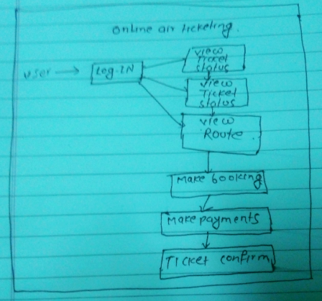

Figure; Rich Picture showing main functions inside system

# 2.2 Information Gathering Techniques

Information gathering techniques refers to the gathering of information through different means or sources. I have used two dissimilar methods for the collection of information which are defined below.

**Interviews**

It refers to the conversation between two or more people for the collection of related information. It is more effective than others methods. We can easily interact with the users and take their requirements, views, ideas etc. It is most common method used everywhere and gives very useful information than others method.

**Focus Group**

It is similar to interviews but it has limited number of selected people i.e. 6 to 10 people. It plays vital role in gathering information like opinion, concern, perception and knowledge of selected people regarding the given topic. It is an effective method to gather client experience. . Focus group is usually applied marketing tools that allows relations to create the product and services that are obstructed.

# 2.3 Feasibility Study

Feasibility study can be defined as the research or investigation that are carried out for the proper completion of project. Any project can be finished effectively by gathering all the requirements through the help of feasibility study. It is guidance to complete project and how a business can run for long term. Feasibility study of different activities like technical feasibility, legal feasibility, economic feasibility etc. are performed to ensure that that no problems occur during the implementation part and to successfully run any organization. It is carried out in the analysis part of the project.

**Types of Feasibility Study**

1. Economic Feasibility

It is done to ensure that the project which is going to develop is within the budget limitation or not. It gives us details of all the expenses of the project. It also helps in the budget identification for different sector within the project. It is analysis that is done to know the profit against the investment made on the project or product.

1. Technical feasibility

It examines whether the existing technology i.e. hardware and software is sufficient or not for the completion of proposed project. If any technical items are lagging, then what technical items should be modified and what new things should be bought i.e. hardware and software.

1. Operational Feasibility

It is type of feasibility which tells us that clients/users will find the product easy to use or not. It also tells us if any kind of training should be provided to users for operating any task. It also tells what things should be needed if training is necessary.

1. Schedule Feasibility

It is the allocation of time for the evolvement of new system. Division of time for all the category is also included. It gives us clear vision about the impact if the product is not delivered in time.

1. Legal Feasibility

Legal feasibility talks about the legal and ethical matters of the project. It ensures that proposed system will meet all the legal requirements and ethical requirements.

# 2.4 Analysis methodology

In this particular project, I have used object-oriented methodology. I have selected this methodology because it simple to understand and also reduces the complexity of software object models. It allows changes and structure are also clear. It enables code reusability as well as software components.

# 2.5 System Requirement Specification (SRS)

The System Requirement Specification is an official announcement of the functional and non-functional requirements of the system. It acts as agreement between developer and client for whom the framework is being manufactured. Its developer duty to provide all the features that are included in the specification. The client agrees to find the item fulfilled in case it gives the restrictions verified in the SRS.

1. **Functional Requirements**

Functional requirements are those requirements which defines what are the main functions inside the system. It points out the main activities of the system like calculation, data manipulation, data processing, login, registration etc.

Functional requirements of my system are:

|  |  |  |  |  |  |
| --- | --- | --- | --- | --- | --- |
| FID | Functions | Data | Rational | Dependency | Remarks |
| F01 | Registration | User details | For users | F01 | Getting access inside system |
| F02 | Login | Username and Password | For users security | F02 | Welcomes to dashboard |
| F03 | View Flight Detail | Time place date of flight | Information for users | F02 | All details of flight |
| F04 | View Ticket Status |  | Price for particular flight | F02 | Prices of all flight |
| F05 | Book Flight | Provide all personal details | Booking flight | F02 | Flight booked |
| F06 | Flight Availability | ticket not booked | flights available for users | F02, F03 | which flights are booked and what are remaining |
| F07 | Booking Confirmation | Booking confirmed | Ensure your flight is booked | F04 | Insurance for your booking |
| F08 | Reschedule  Ticket | Edit flight information | Making new updates | F04, F07 | Editing all flight information for new booking |
| F09 | Ticket Cancelation | Cancel ticket booking | Due to some reasons | F04, F07 | Cancelation of booked ticket |
| F10 | Phone Access | Phone Number | For customers | F02 | Direct contact to head office |
| F11 | Update Users Profile | User information | For users to edit information | F01, F02 | Allow users to update their information |
| F12 | Admin Login | Admin Details | Admin | F12 | Admin can login |
| F13 | Admin Profile update | Admin Details | Admin | F12 | Admin can update profile |

Figure: Functional requirements

1. **Non- Functional Requirement**

Non-Functional requirements refer to the products excellence product. It is generally used to justice the systems operation. They are basically categorized into two different sectors.

1. Execution qualities: Usability
2. Evolution qualities: Testability, Maintainability

|  |  |  |  |  |  |
| --- | --- | --- | --- | --- | --- |
| **Nid** | **Functions** | **Data** | **Rational** | **Dependency** | **Remarks** |
| N01 | Responsive | - | Gives different solutions |  | Fits in screen of different size. |
| N02 | Usability | - | Easy to use, User friendly |  | Users must find it easy to use |
| N03 | Maintainability | - | Change Adaptability |  | Should be maintained easily in case of errors |
| N04 | Reliable | - | Accurate output |  | Must give correct output of given input |
| N05 | Robust | - | Run on any platform |  | Must be able to run on several platforms |
| N06 | Multi-Browser support |  | Run on multiple browsers |  | Supports multiple browsers |
| N07 | Scalability |  | Workload handled easily |  | Data flow handled easily |

Figure: Non-Functional requirements

1. **Prioritization**

Prioritization means giving focus to those functions that are most to the system. It ensures that important things are managed accordingly. It acts as a rule to project team for ranking items. It also helps in allocating more time to those which are in top priority.

In this particular project I have used **Moocow** prioritization

• It guides vital and expenditure plans.

• It inspires people to review on their requirements.

• It impulses people to plan and achieve improved work.

**Moscow (Must, Should, Could, Wont)** it is basically originating form DSDM.

**Must have:** It enlists the requirements that are most to the system. It plays vital role in project success because wrong requirements can lead to failure. It is like basic needs to the system and are not negotiable.

**Should have:** It enlists the requirements that are important but not the vital. They can be considering important but shouldn’t be included always.

**Could have:** It enlists the things that seems necessary but important to the system. Its implementation depends upon the time remaining to complete the project.

**Won't have:** These requirements are not necessary but can be implemented in future at development phase if needed. They does not play any important role in the project success.

**Moscow Prioritization**

|  |  |  |
| --- | --- | --- |
| **ID** | **Functionality Requirement** | **Moscow** |
| F01 | Registration | Should have |
| F02 | Login | Must have |
| F03 | View Ticket Status | Must have |
| F04 | View Flight Details | Must have |
| F05 | Book Flight | Must have |
| F06 | Flight Availability | Should have |
| F07 | Booking Confirmation | Must have |
| F08 | Reschedule Ticket | Should have |
| F09 | Ticket Cancellation | Should have |
| F10 | Phone Access | Should have |
| F11 | Update Users Profile | Could have |
| F12 | Admin Login | Must have |
| F13 | Admin Profile Update | Could have |
|  | | |
| **ID** | **Non-Functional Requirements** | **Moscow** |
| N01 | Responsive | Must have |
| N02 | Usability | Must have |
| N03 | Maintainability | Must have |
| N04 | Reliable | Should have |
| N05 | Robust | Must have |
| N06 | Multi-Browser Support | Must have |
| N07 | Scalability | Won't have |

Figure: Moscow prioritization

# 2.6 System Architecture

System architecture is theoretical model that characterizes the structure, conduct and perspective on framework. It portrays the portrayal of entire framework. For this venture, I have use 3-level structure. System engineering is applied model that characterizes the structure, conduct and perspective on framework. It depicts the portrayal of entire framework. For this task, I have use 3-level structure.

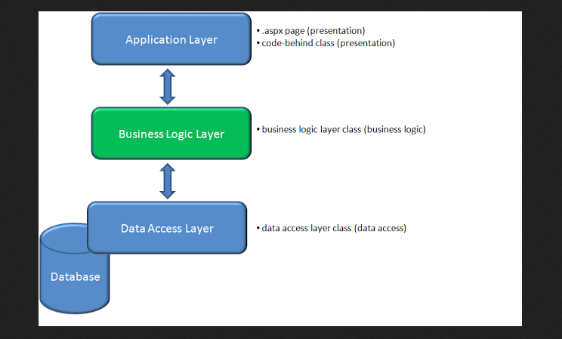

Figure: Three tier structure

**Model**

The model handles all the data related logic that user work with. This represent data that is transfer between view and controller.

**View**

The view handles all UI logic of application.

**Controller**

Controller acts as intermediary between model and view to process incoming requests and logic

# 2.7 Use Case Diagram

Use case diagram is the diagramed representation of what functions does the actor i.e. admin, user do in the respective system. It gives the maximum functionality of any system. It allocates the function assigned to different all the actors involving inside the system. They are used to collect the system requirements containing internal and external impacted.

The purpose of Use Case diagram is given below:

* It gets the dynamic piece of the system.
* It shows how on-screen character cooperate with the system.
* The framework design is approved.
* Determined content of system.

The symbols used in the use case diagram are given below. They help us to show interaction between system and actor.

**System:** By using rectangle shape draw our boundaries of the system which contains the use cases. Actor should be placed outside the system boundaries.

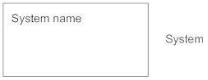

**Actors:** Actors are something that interact with our system .it is denoted by the symbol.

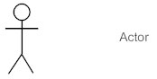

**Use Case:**  Use case is oval in shaped which represent various uses that an actor might have. It is denoted by symbol the symbol.

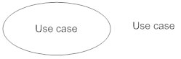

**Relationship:** Relationship can be labeled by arrow either uses or extends among use cases. To perform a task on use case is needed by another is indicates by uses relationship where extends indicates optional under a certain use case.

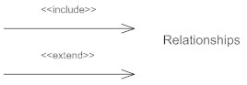

Use Case Diagram of My System

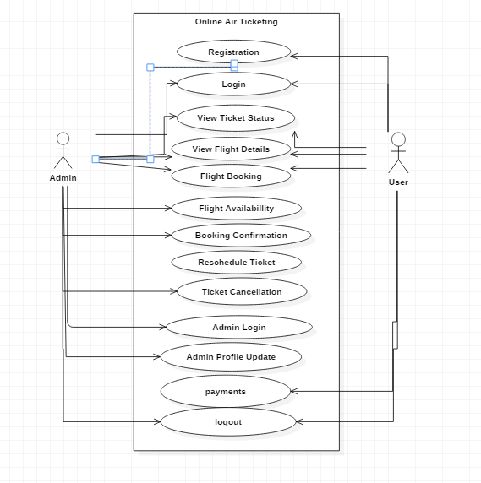

Figure: Use case diagram for admin and user of system

# 2.8 NLA (Natural Language Analysis)

Natural Language analysis is a method of finding nouns and verbs which will be possible classes and methods in a system. It is one of the best ways of finding the classes and behaviors. It will minimize the redundancy and the efficiency of system is also increased.

**Scenario**

In the present situation people has become very modern and technology-dependent. They want fast and easy method for communication as well as in working platforms. They don’t want to waste their valuable time in unnecessary things like standing on queue for a simple work. It is like wasting time for them. They want something which they can access from their home by using their mobiles phones, computers or by using internet services. They are using technology in their day to day activities like purchasing products, ordering goods, foods, air ticket booking, booking movie ticket etc.

Online Air Ticketing is a web application where people can book ticket for specific date as well as they can cancel ticket if emergency occurs. It also includes price of the ticket with ticket class like normal, business, economy etc. You can also see the time of flights of many airways’ companies. It also shows the flights are available or not. As you travel by air ticket, you can also search for the hotel around local areas using this web portal. You can easily book ticket a month before travelling. It will have facility of phone access and rescheduling ticket. You can get cheapest flight for several places of country using this application. All you need to do is register first in application and you can book air ticket simply by browsing. Tickets are available for all the airports inside Nepal and it has 24 hours’ services. Users can also cancel the ticket if emergency occur. Admin can login and edit their profile inside the system.

**Identifying Nouns and Verbs**

|  |  |
| --- | --- |
| **Nouns** | **Verbs** |
| People, Platform, Queue, Mobile Phones, Computers, Internet, Flight, Products, Goods Ticket Booking, Movie Ticket, Online, Application, Registration, Class, Business, Economy, Companies, Available, Admin, Nepal, Login, Profile, | Fast, Communication, Waste, Access, Purchasing, Ordering, Booked, Includes, View details, Cancel, Standing, Occurs, Search, Rescheduling, Travelling, Browsing, Registered, Edit, Make payments, |

Figure: Nouns and Verbs identified from NLA

After removing all the synonyms from the identified nouns and verbs and ambiguous word. Also, the noun out of scope and technical words are removed. Finally, we are able to find the given classes and behaviors inside the system.

|  |  |
| --- | --- |
| Classes | Functionality |
| Admin, login, Registration, Booking, Confirmation | Users Login, Users Registration, View Flights Details, View Ticket Status, Reschedule Ticket, Cancelation, Profile Update, Make Payments, Availability |

Figure: Classes and Functionality from NLA

# 2.9 Initial Class Diagram

System static view is representing by class diagram. It shows the classes within a model. By consuming the outcomes of the crc procedure initial class diagram is established. It can signify all these things fairly effortlessly. Icon of the class is just rectangles which is separated into the three components.

* The uppermost compartments specify the name of the class.
* The middle section specifies a list of attributes.
* The bottom section specifies a list of processes (Methods).

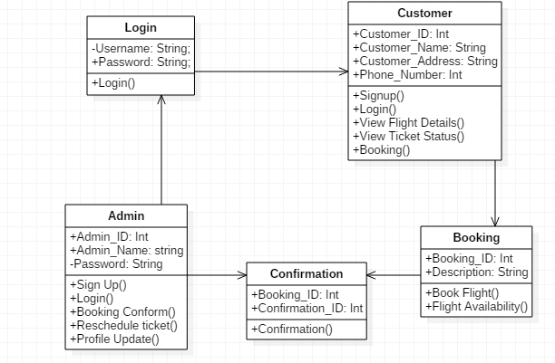

Figure: Initial class diagram with attributes and operation

# Conclusion

In the analysis period, I have done several things. All the requirements were identified. Then the functional and non-functional requirements were identified. After that Moscow prioritization plays an important role in identifying the important requirement for the system. Design was marked by the help of MVC. I have utilized use case diagram that shows the interaction of actor with the system and at last initial class diagram was established.

# 3 Designing

# 3.1 Introduction

Designing is supposed to be an important part in the development process of software. Design Specification portrays how system can perform the necessities which is sketched in functional requirements. Depending upon the frame. This can include guidelines on testing particular requirements, arrangement settings, or audit of capacities or code. Here in the functional specification all outlined requirements must be addressed.

# 3.2 Tools

In this particular project, I have used different tools or software for the construction of ER diagram, Class diagram, Database, Activity diagram etc.

* IDE (Integrated Development Environment) = Sublime
* Database = MySQL
* Class Diagram, Use case diagram, Activity diagram, and sequence diagram = Star UML
* Entity Relationship Diagram = Visual Paradigm

# 3.3 Structure Model

It is the static structure of the framework which demonstrates the communication, relationship of the object. It comprises of the Entity Relationship and class diagram which is given beneath. Structural models of software show the association of a system as far as the segments that make up that framework and their connections. Here we will center around class diagram for displaying the classes structure in a software system.

# 3.3.1 Class Diagram

The relationship between class and showing its methods or behavior and the attributes are called class diagram. It furthermore establishes the cardinality joining among or between the classes. It gives vision of an explanation of the model into the code. It is furthermore used for modeling that symbolizes the opinion responsibilities of the framework.

Final class diagram for online air ticketing

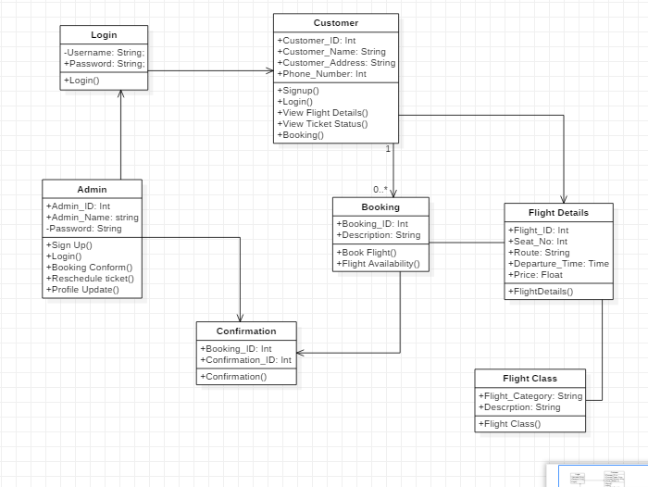

Figure: Final Class Diagram for Online Air Ticketing

Justification: Above class diagram includes all the classes involved in the online air Ticketing. Customer and Admin need to log in inside the system and booking are performed by customer and confirmation is dependent of admin. Booking also uses flight details and flight class.

# 3.3.2 Data Flow Diagram

Data Flow Diagram can be defined as the movement of data inside the system or framework. It consists of information, output, information sources etc. It also consists of sub process through which information passes.

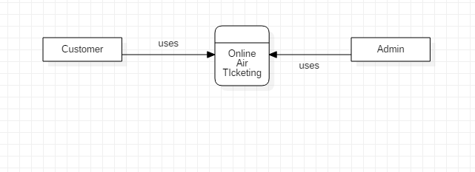

Figure: Level 0 Data Flow Diagram

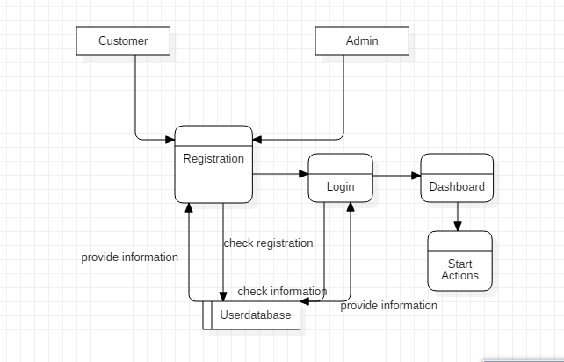

Figure: Level 1 Data Flow Diagram

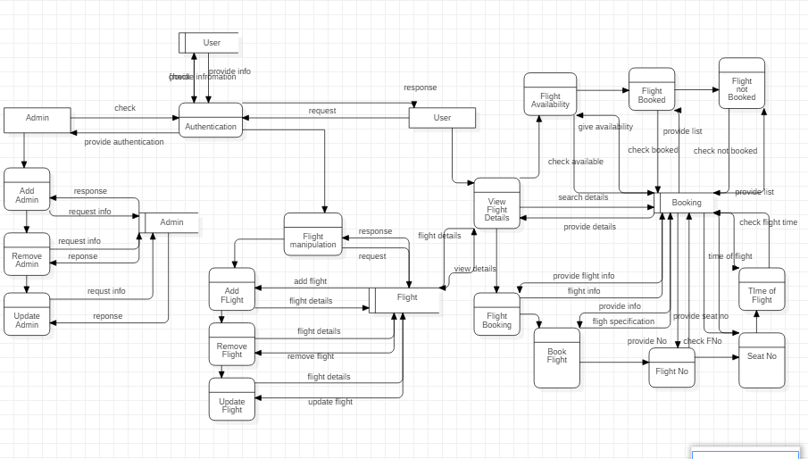

Figure: Level 2 Data Flow Diagram

# Justification

The above diagram shows the interaction inside the system. It includes entity and their behavior. Sequence diagram shows the data fetching from database. It is showing all the functions of all the entities.

# 3.4 Data Modelling

Data Modelling is a procedure used to characterize and inspect information requirements expected to help the business forms exclusive the extent of relating data frameworks in associations. In this manner, the procedure of information representative includes proficient information modelers working closely with business partners, just as potential clients of the data framework.

# 3.4.1 Entity Relationship Diagram

Entity Relationship Diagram can be defined as the graphical representation of entities and relationship between them. They can also be called as entity relationship model. It relies mainly on view of realistic world which consist of an object collection known as entities. It also includes attributes related with entities.

Entity Relationship Diagram for Online Air Ticketing

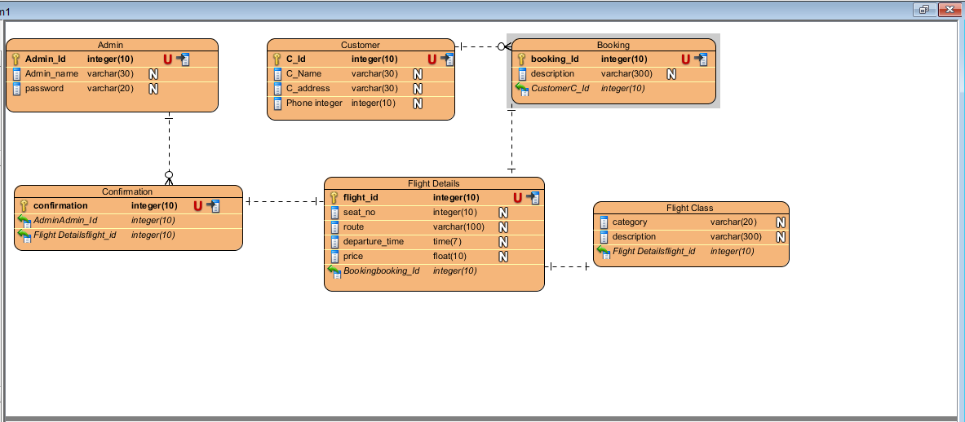

Figure: Entity Relationship Diagram of online air ticketing

# Justification

The above diagram shows the ER diagram which is showing entities like admin, customer, booking, confirmation, flight details, flight class. Customer and booking have one to many relations and other have one to one relationship.

# Data Dictionary

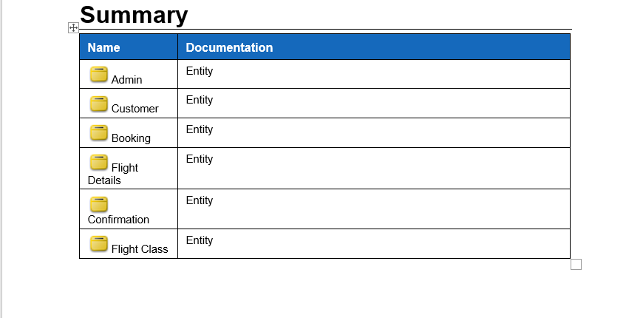

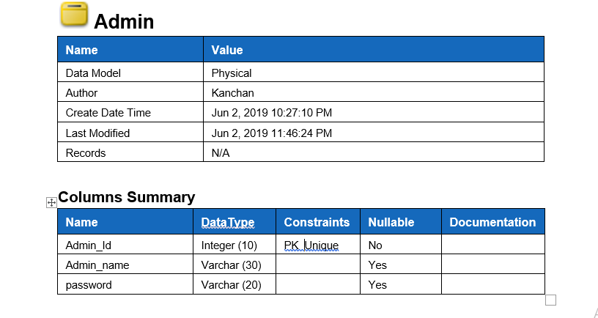

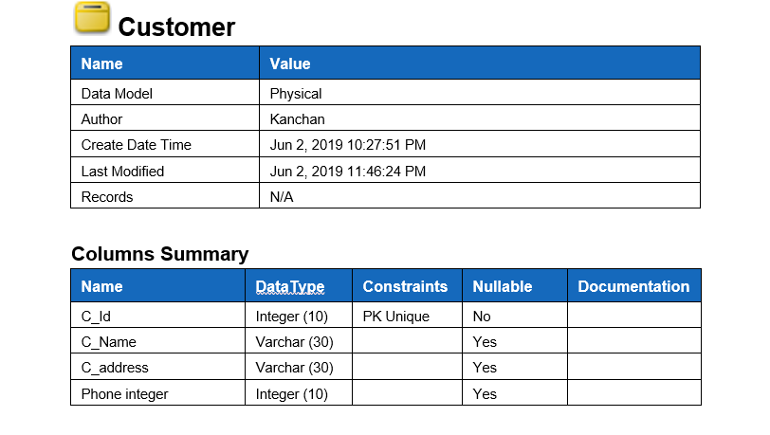

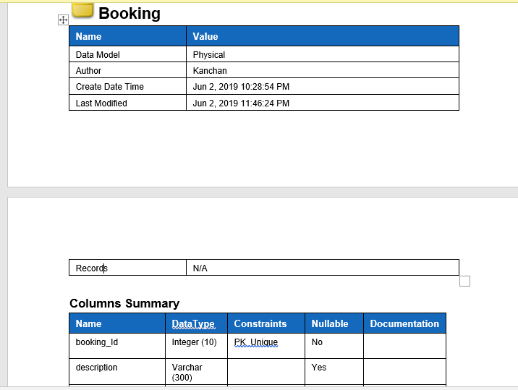

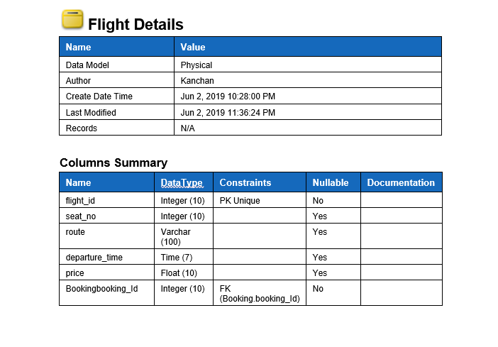

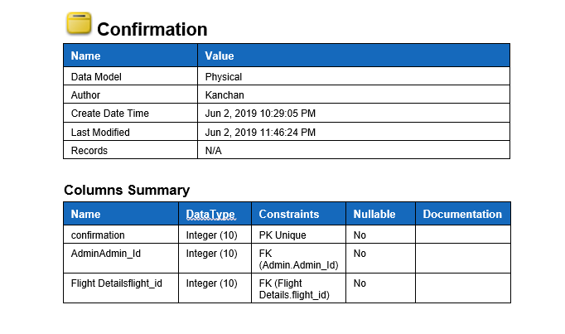

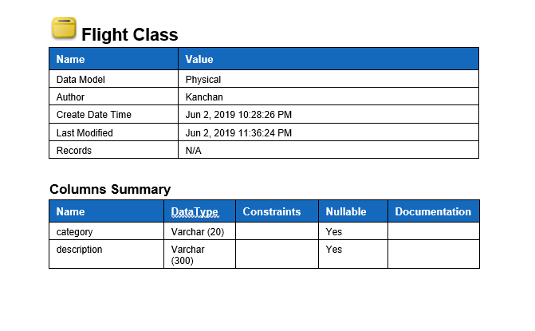

Figure: Data Dictionary for online air ticketing

# 3.5 Behavioral Model

Behavioral model is called dynamic model. It is time dependent so it can have changes while running. Some of the importance of behavioral model are.

* Demonstrate the controlled architecture of the platform
* Meeting the needs of framework
* Architecture of system are explainable

# 3.5.1 Activity Diagram

Activity Diagram can be defined as the flow of activity inside the system. It shows the systematic order of flow of all the activities inside the system. It’s a graphical representation of overall system functions.

Activity Diagram for Online Air Ticketing

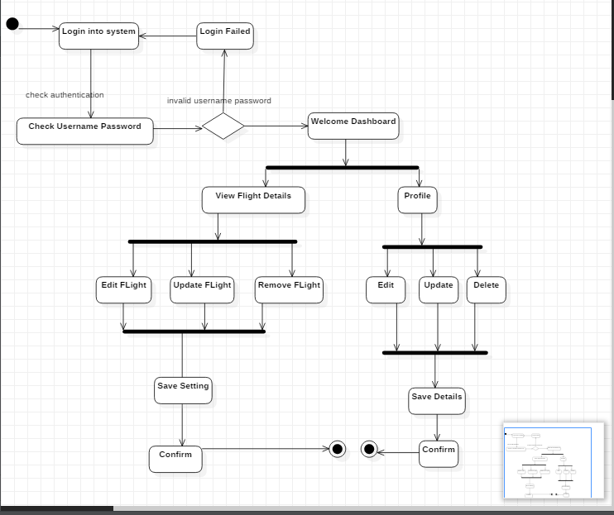

Figure: Activity Diagram for Admin

# Justification

The above diagram is an activity diagram for admin which includes all the functions that are performed by admin inside the system. It gives clear look of what are the task that are allocated for admin and his/her criteria.

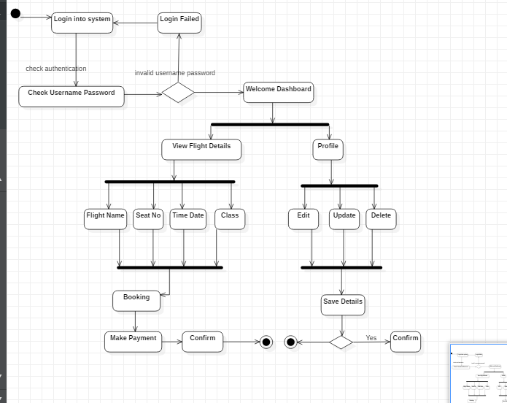

Figure: Activity Diagram for Customer

# Justification

The above diagram is an activity diagram for customer which is showing all the activities related to customer inside the system. What things are allowed to user and what things are not allowed to them. It also shows the flow all functions.

# 3.5.2 Sequence Diagram

Sequence Diagram can be defined as the diagram that shows interaction in a sequence. It shows the classes and object involved in the system. It is mainly related to the use case of the system.

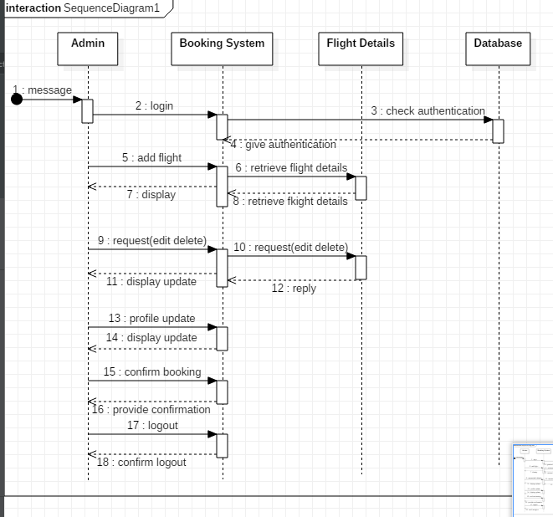

Figure: Sequence diagram for Admin

# Justification

The above sequence diagram is for admin it shows the task of the admin in sequence. It includes all the tasks performed by the admin in order. Here four entities are used and functions are performed inside them in sequence.

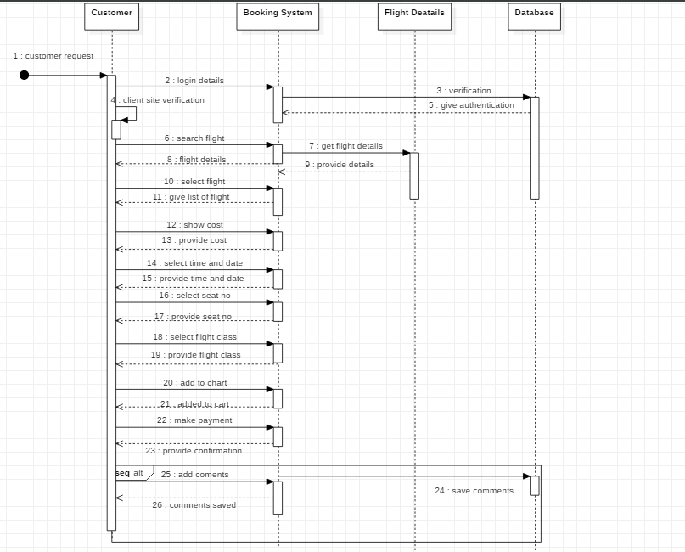

Figure: Sequence diagram for Customer

# Justification

The above is sequence diagram for customer which includes four entities and functions area performed between them. It consists of lifeline and message arrows which is performing tasks inside entities.

# 3.5 Prototype (UI Design)

A prototype is an early example, model, or arrival of an item operated to test an idea or procedure or to go about as a thing to be copied or increased from. It is a term applied in a collection of surroundings, counting semantics, plan, gadgets, and programming. A model is normally used to evaluate additional plan to advance exactness by framework specialists and customers.

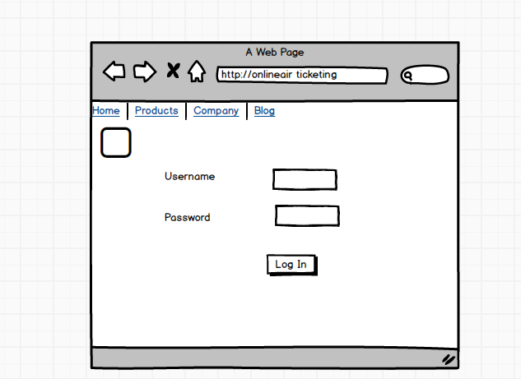

Figure: Prototype for Login

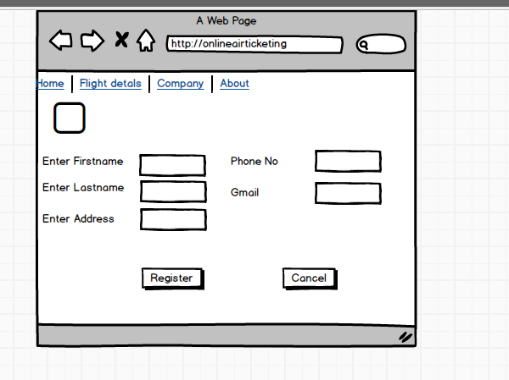

Figure: Prototype for Registration

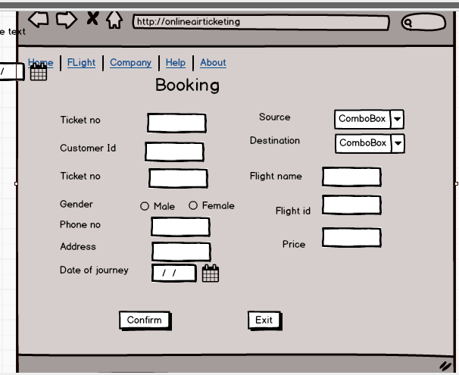

Figure: Prototype for Booking

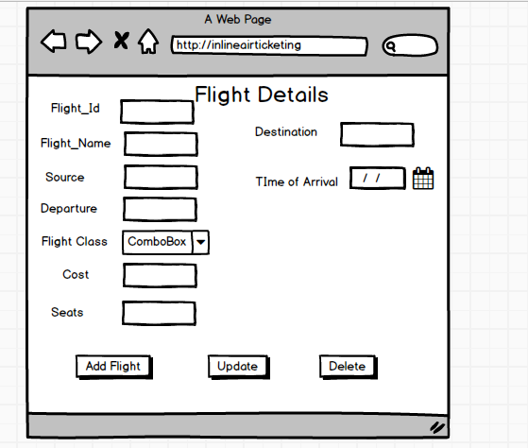

Figure: Prototype for Flight Details

# 3.6 Conclusion

Finally, the designing part of online air ticketing came to an end. It includes structural model which consists of class diagram and data flow diagram. It also consists of behavioral model which includes entity relationship diagram, activity diagram and sequence diagram. Prototype is also designed which is showing outlay of interface inside the system. After designing implementation process will be carried out.

# Chapter-4 Implementation

Implementation can be defined as the conversion of theoretical or logical views into real world or practices. All the things which are mentioned in proposal, analysis, design should be implemented in system in implementation part. It gives assurance that the new build system has these type of functionality and UI design. It should be done correctly and wisely. The codes and UI design of the system are shown in **appendix.**

# 4.1 Programming language

Programming language is a methods or means with the help of which a complete system is designed. It helps to build a system as it is used only in programming sector. There are different types of programming language in market like PHP, JAVA, Android, C, C+, C# etc. which are converted into binary number i.e. 0 and 1 through the use of interpreter and compiler so that computer could understand it.

For this particular project, I have used core PHP for the execution logical views into real world implementation. I have also used My SQL for creating all the database and for storing data inside it. PHP refers to Hypertext Preprocessor and it is also called server-side programming language which is mainly used to build web-based application. In this project, I have also used MVC design pattern as controller for the system.

# 4.2 Development environment

Development environment refers to all the process and tools that are used in the development and creating of new system. It is also called a physical environment as it gives all the equipment for creating proper software. All the tools that are used in the success of project comes under developing environment of the system. The most common example of integrated developing environment is Microsoft visual studio.

In this project, I have used some of the tools for the project completion. I used sublime for writing all codes of system. XAMPP server was used for as a system viewing server. Other tools used in this project was balsamic which helped me in UI design of the system. Staruml was used to do the designing part of the project and MySQL server for maintaining all database. I also used MVC pattern for controlling vital functions inside the system and to maintain code standards.

# Chapter 5 Testing



Fig: Testing of program

Testing can simply be defined as the process executed in any program with the objective of finding errors or bugs. For the good software or website, a proper application with errors free should be provided. Testing should be performed in a way so that it can find all the bugs inside the program in order to fix it.

There are a lot of testing methods for a program or any other application. Some of them are listed below:

* Unit Testing
* Black Box Testing
* Integration Testing
* Functional Testing
* Acceptance Testing
* Beta Testing

Among of above testing methods, I have chosen Unit Testing and Black Box Testing.

**Black Box Testing:** It is a type of test where test case is obtained through analysis and design view if the system. It checks whether correct value is assigned or not for valid and invalid inputs. Coding part can also be neglected as it is performed on UI design.

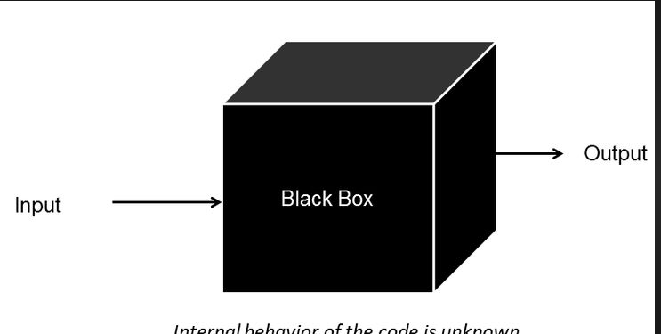

Fig: Black Box Testing

**Test Name: Registration Test**

Pre-Condition: Customer should get access to register inside the system.

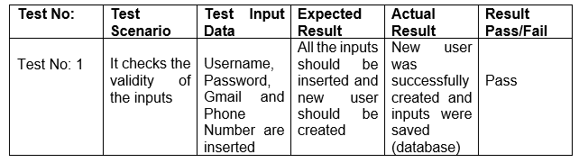

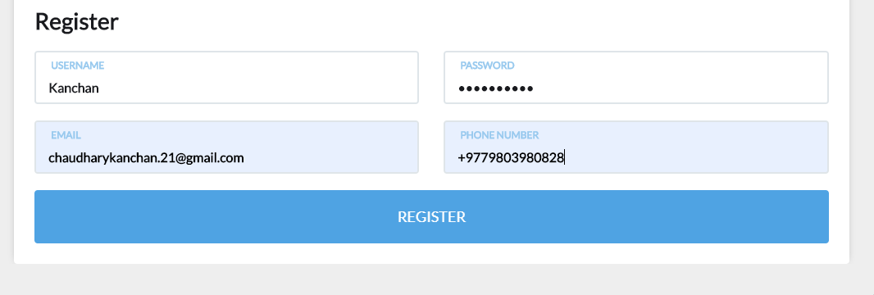

Fig: Inputs for user registration

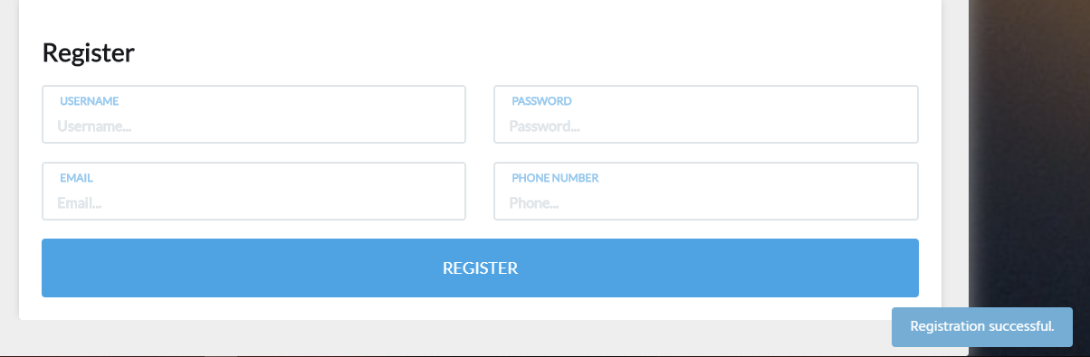

Fig: Successful message for user registration

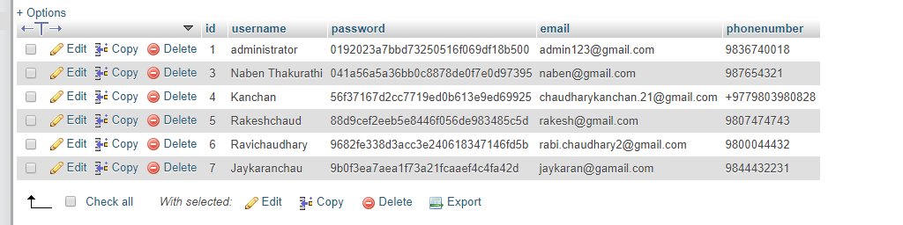

Fig: Registered data in database

**Test Name: Log in Test**

Pre-Condition: The user should enter dashboard of the system

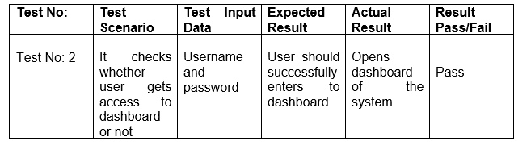

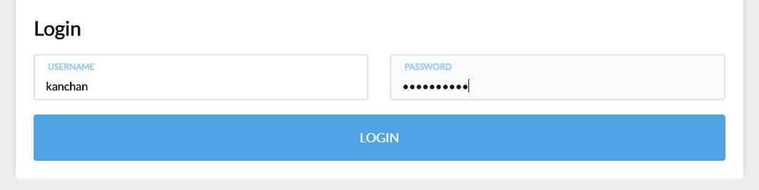

Fig: Entering username and password for log in

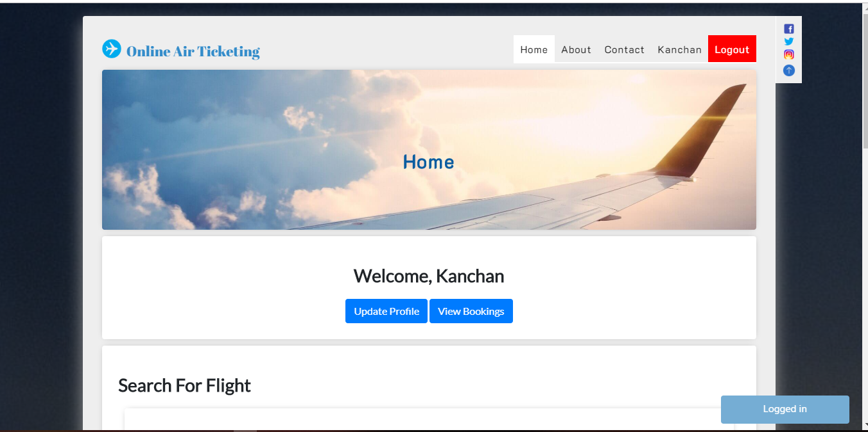

Fig: Login successfully and opens dashboard

**Test name: Valid and Invalid Test**

Pre-Condition: Message should be displayed

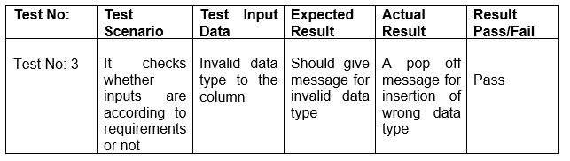

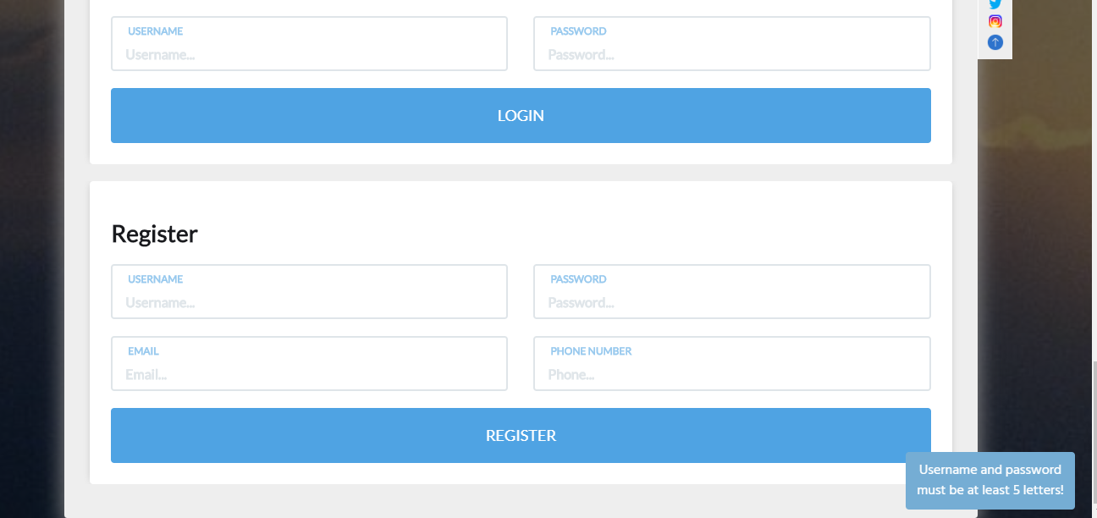

Fig; Message for invalid data type insertion



Fig: Message for insertion of invalid data

**Test Name: Data Insert Test**

Pre-Condition: The inserted data should be saved inside the database

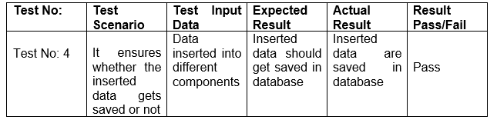



Fig: Data inserted inside database

**Test Name: Update Test**

Pre-Condition: Data should get updated

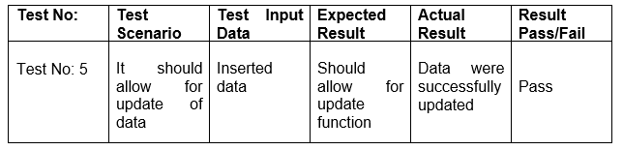

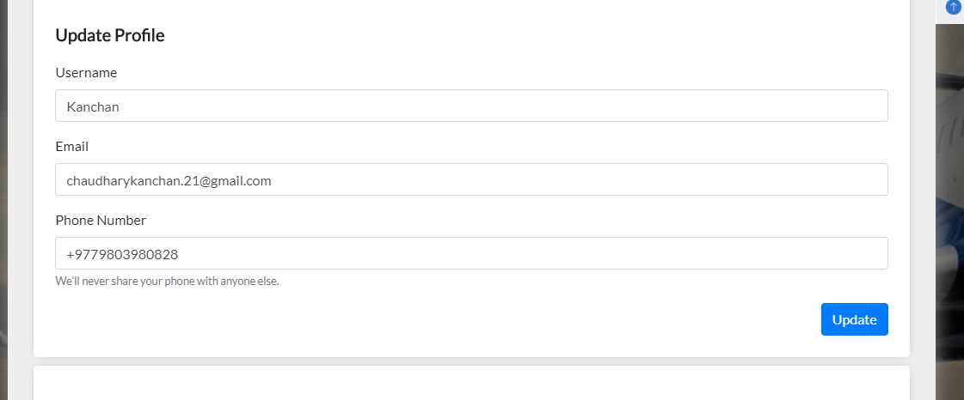

Fig: Update of inserted data

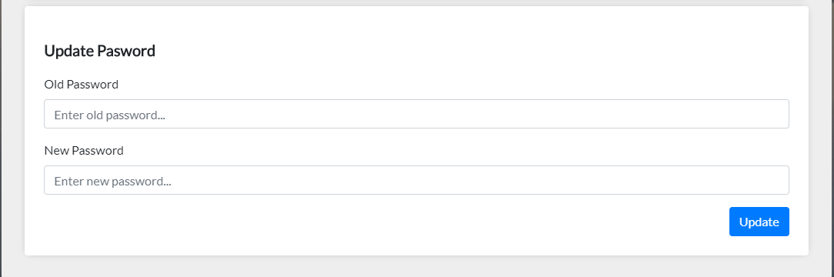

Fig: Update of inserted data

**Test Name: Delete Test**

Pre-Condition: Should allow for data deletion

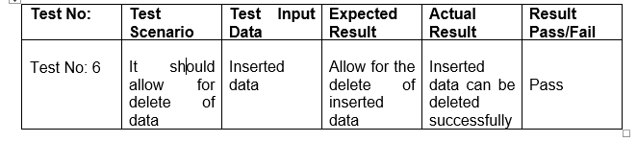

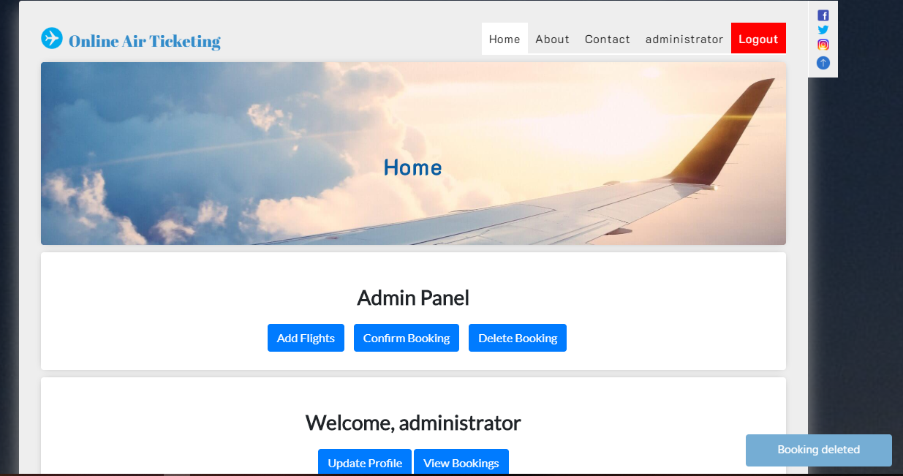

Fig: Delete process execution of inserted data

**Test Name: Contact Us Test**

Pre-Condition: Should allow user to contact to admin

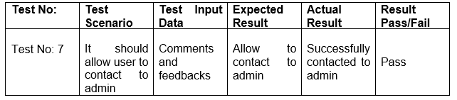

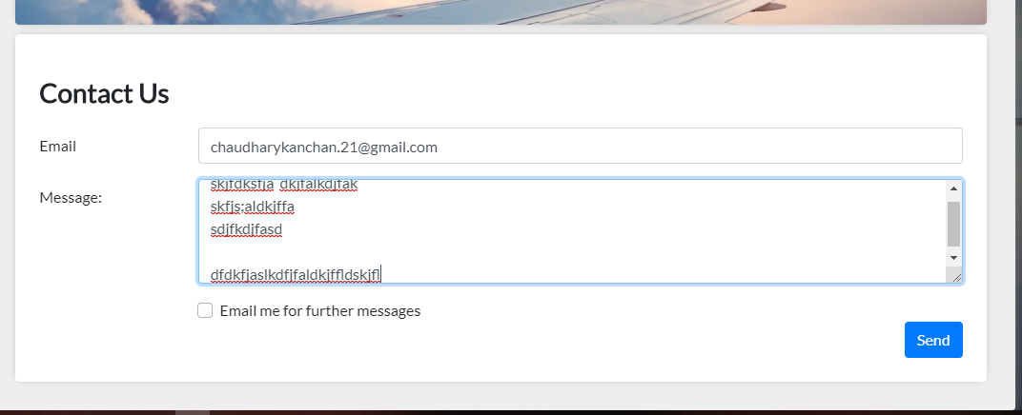

Fig: Contact Us page in program

**Test Name: Registering without any kinds of inputs**

Pre-Condition: Registration Unsuccessful

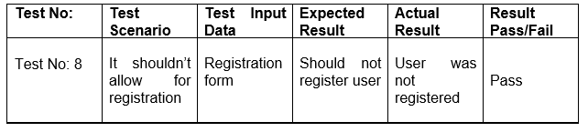

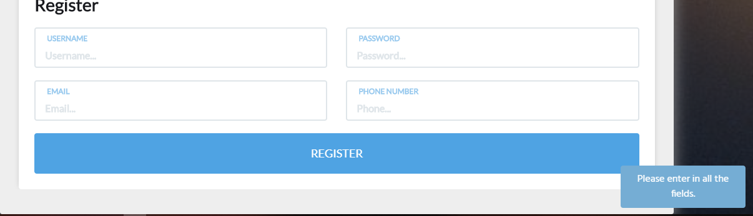

Fig: Registering without inputs

**Test Name: Login test with wrong username and password**

Pre-Condition: Login should be unsuccessful

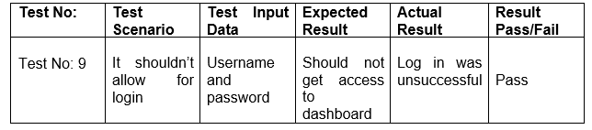

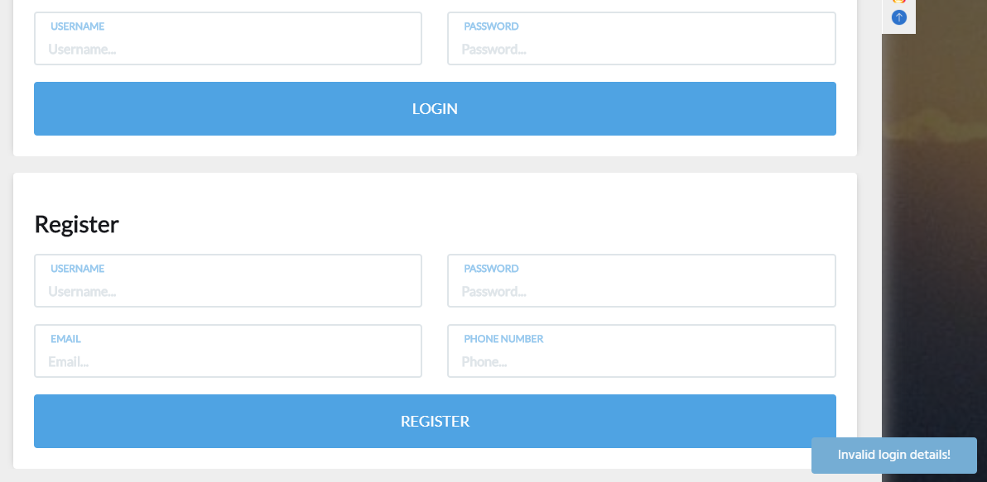

Fig: Invalid username and password

**Test Name: Registration with invalid email**

Pre-Condition: Should show notification for incorrect email

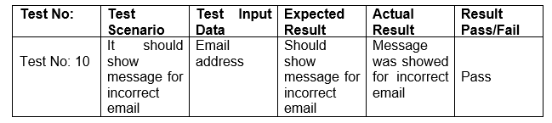

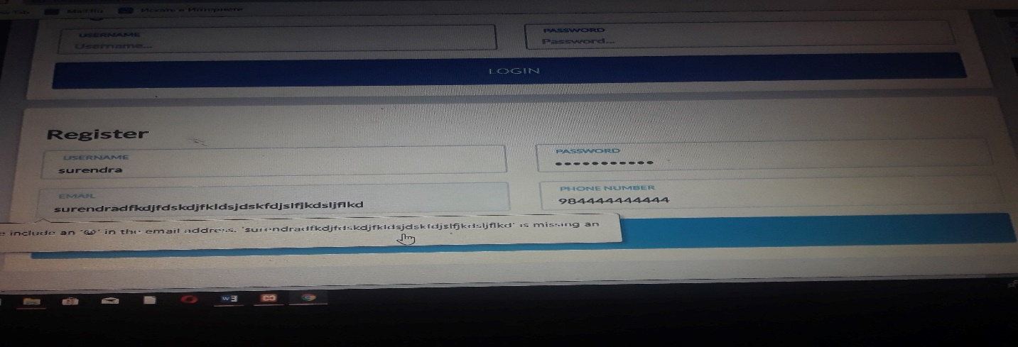

Fig: Registration with invalid email

**Test Name: Registration with valid email**

Pre-Condition: Should allow for registration

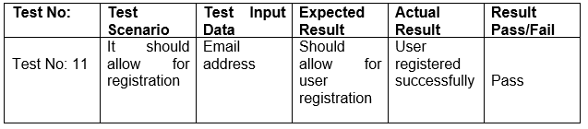



Fig: Registration with correct email

**Test Name: login with wrong password**

Pre-Condition: Should allow to log in inside the system

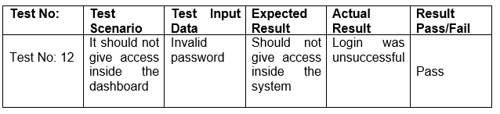

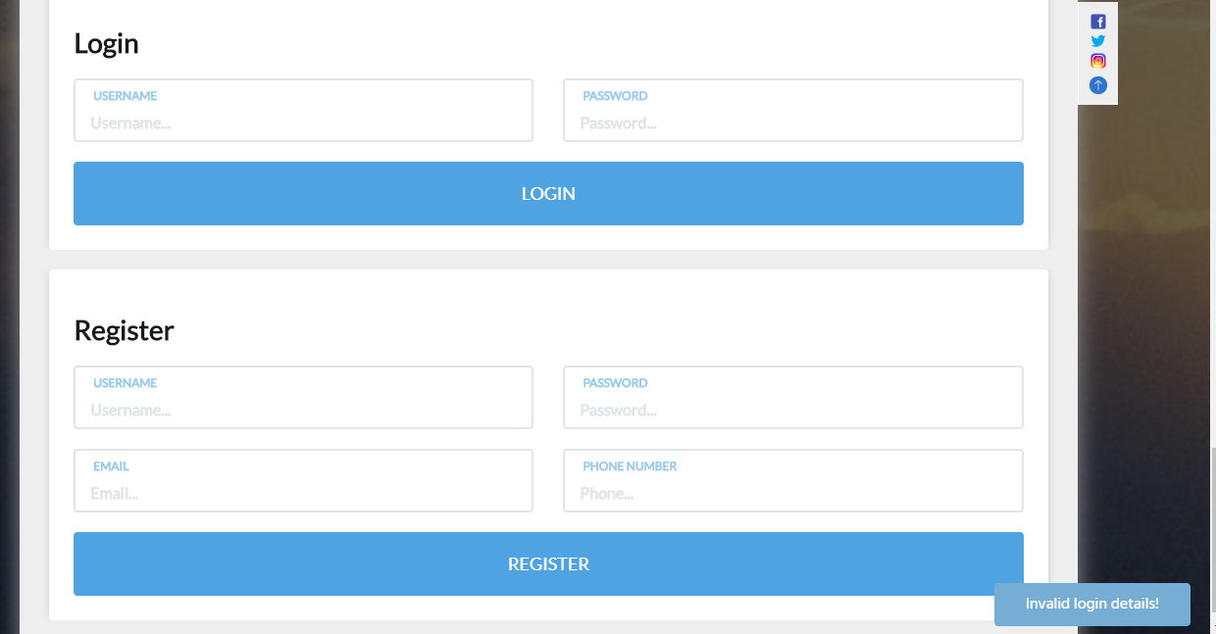

Fig: Login with invalid password

**Test Name: Contact us without data test**

Pre-Condition: No comments should be registered

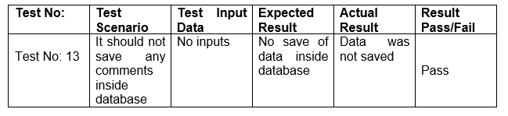

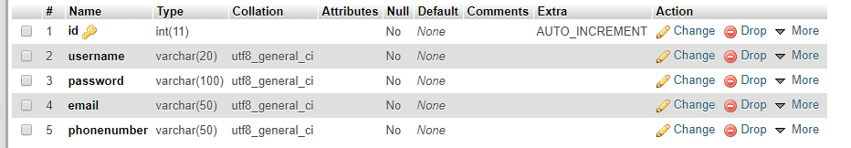

Fig: No comments were saved

**Test Name: Searching flight without inputs**

Pre-Condition: Should ask to fill data

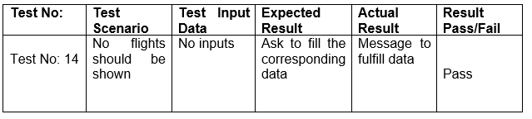

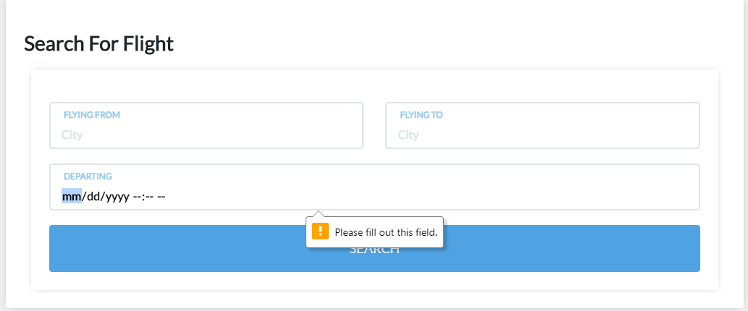

Fig: Searching flights with no inputs

**Test Name: Profile update**

Pre-Condition: Should allow for profile update

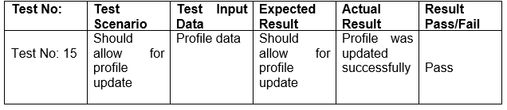

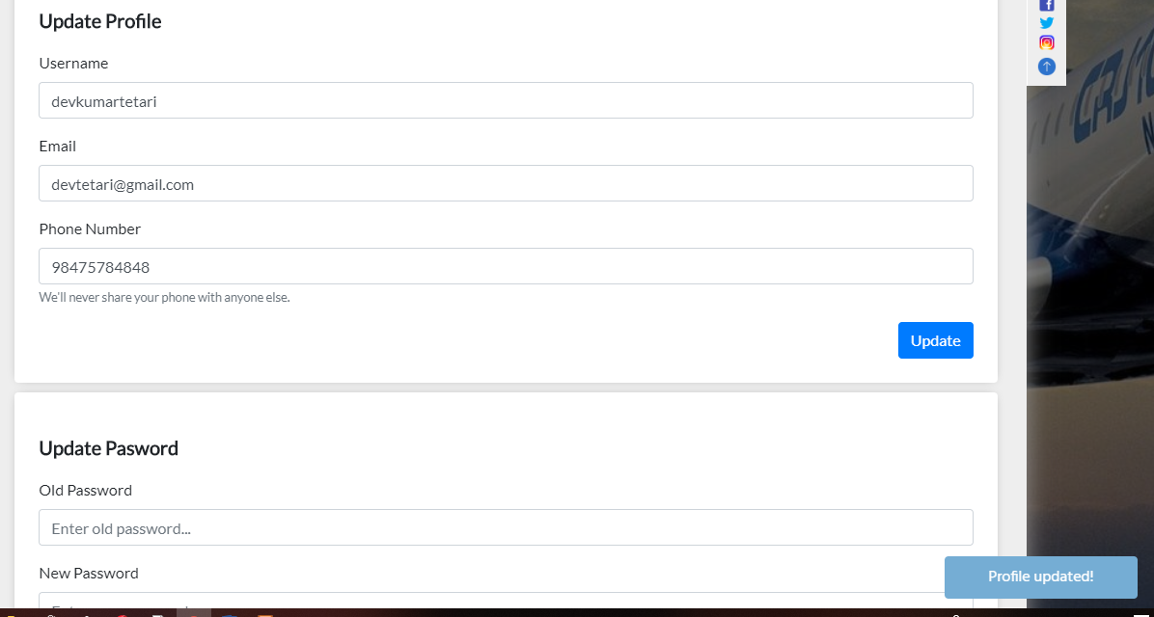

Fig: Profile updated successfully

**Test Name: Update password test**

Pre-Condition: Should allow for password update

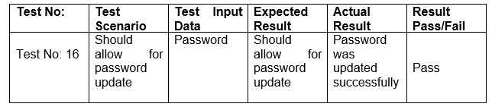

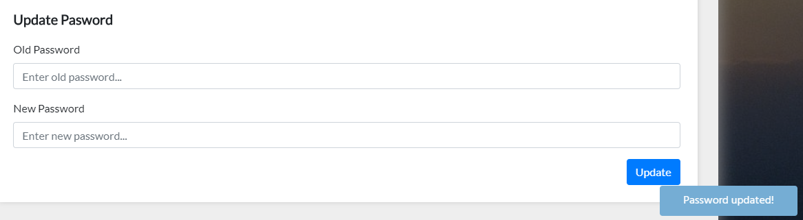

Fig: Password updated successfully

**Test Name: Add flights test**

Pre-Condition: Should allow for flights adding

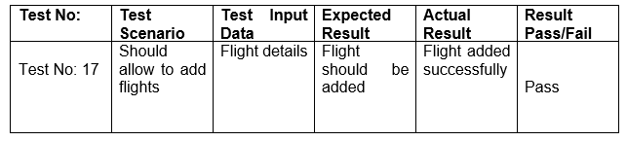

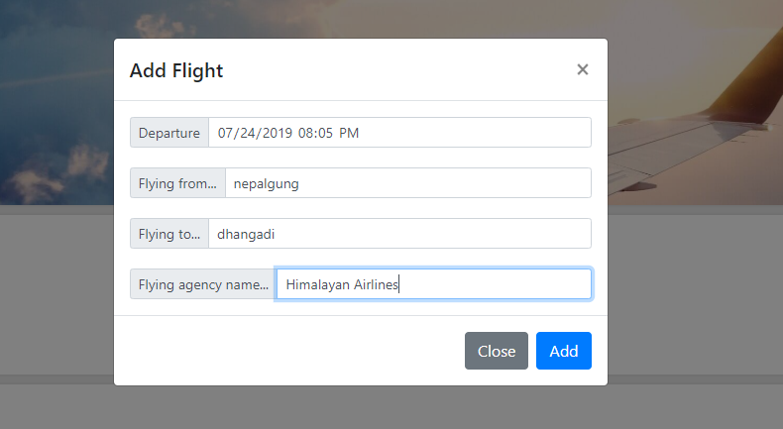

Fig: Details of the flight for adding

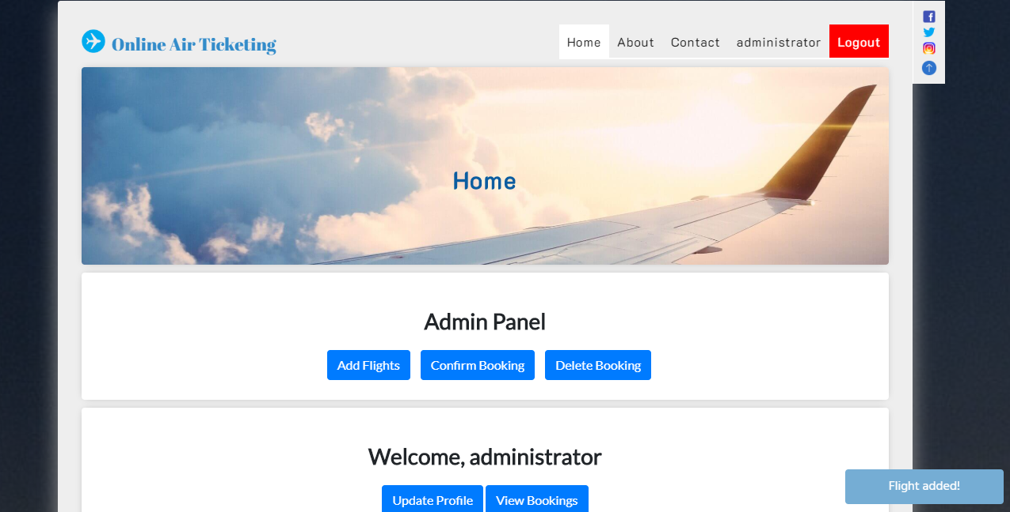

Fig: Flight added successfully

**Test Name: Delete Booking test**

Pre-Condition: The booking should be deleted

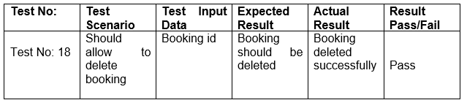

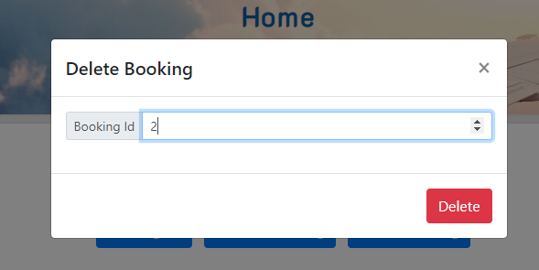

Fig: Booking id for deleting



Fig: Booking deleted successfully

**Test Name: Booking Confirmation test**

Pre-Condition: Should show message for confirmation

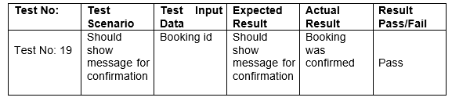

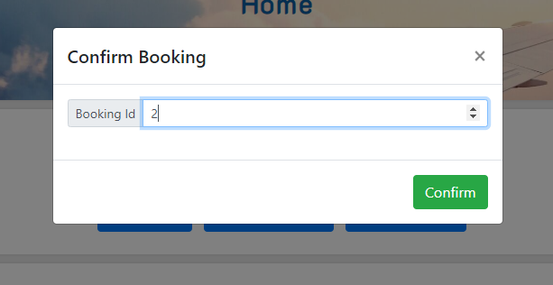Fig: Id for confirmation

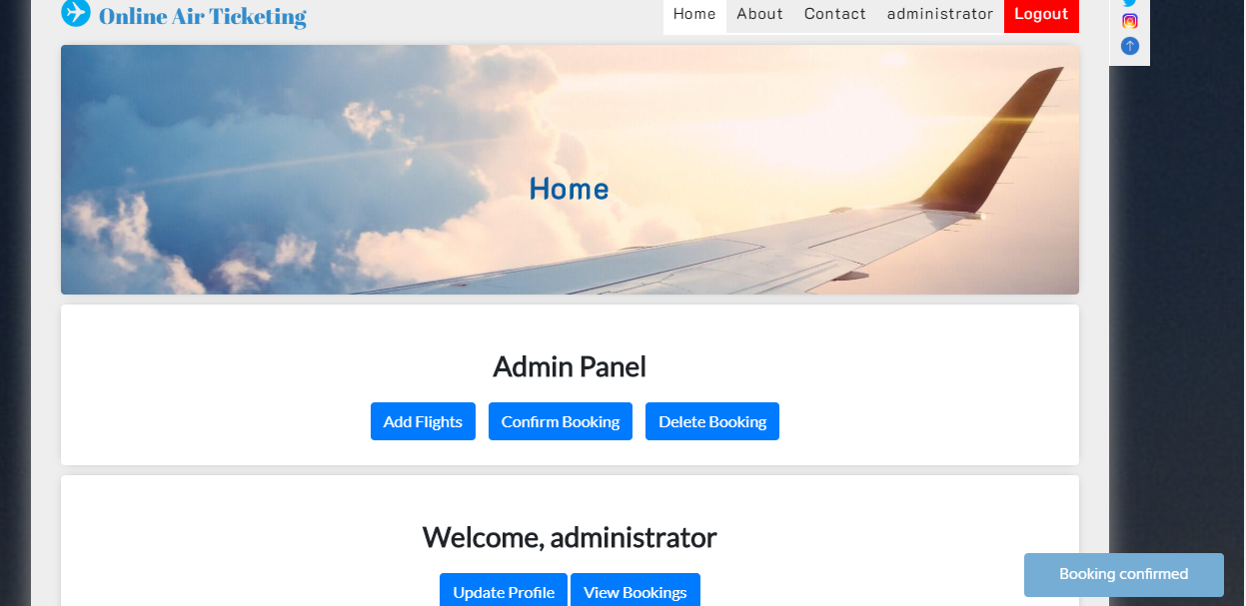

Fig: Message for confirmation

**Unit Testing:** It is kind of testing where particular units/components are tested thoroughly. This is performed in order to confirm that all the components of the particular things perform effectively. It is often performed by the software engineer by the use of test input and comparing yields.

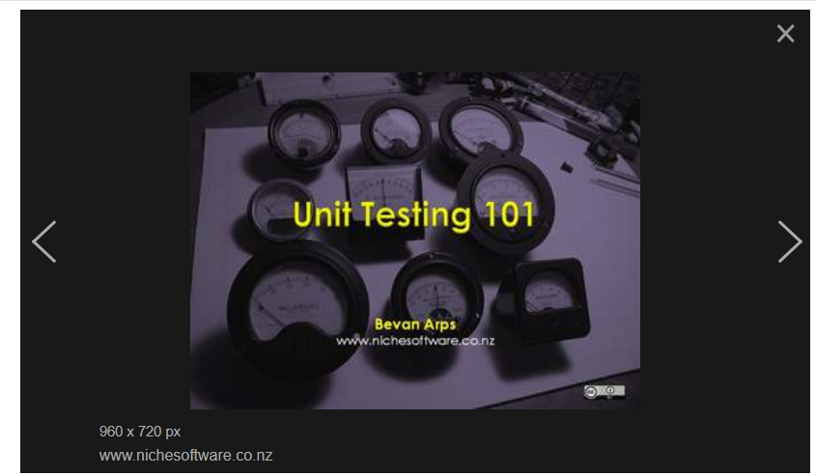

Fig: Unit testing

**Test Name 1: Login success test**

Pre-Condition: Should show pass message

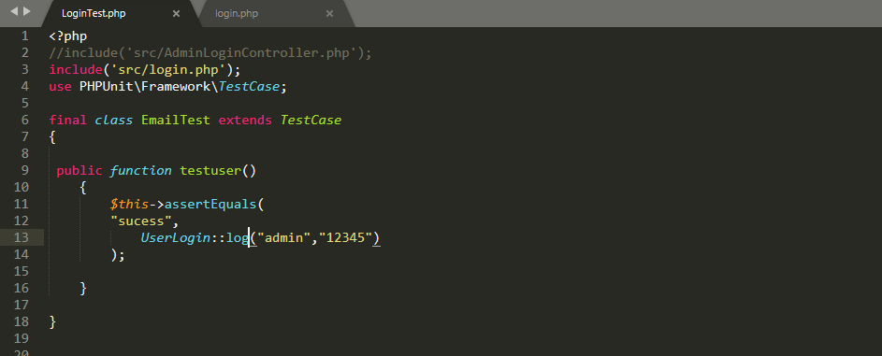

Fig: Code for login success test

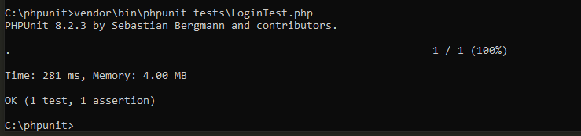

Fig: Message for login success

**Test name 2: Register success test**

Pre-Condition: Should not show any errors

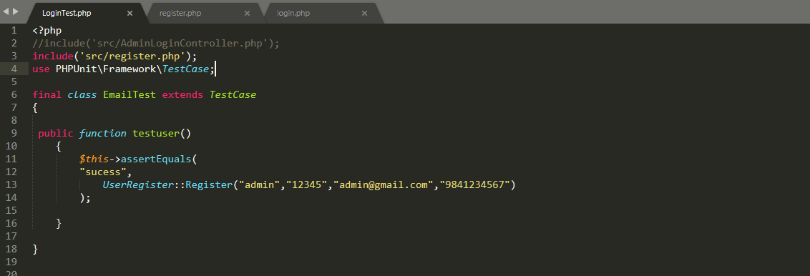

Fig: Code for register success test

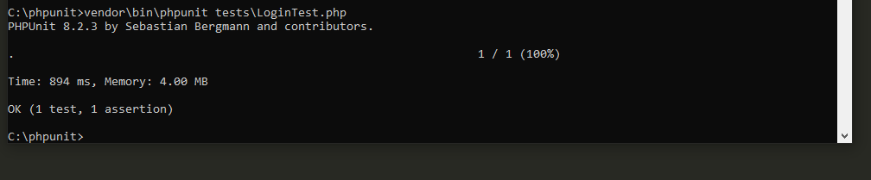

Fig: Message for register success test

**Test name 3: Booking confirmation test**

Pre-Condition: Should not show any errors

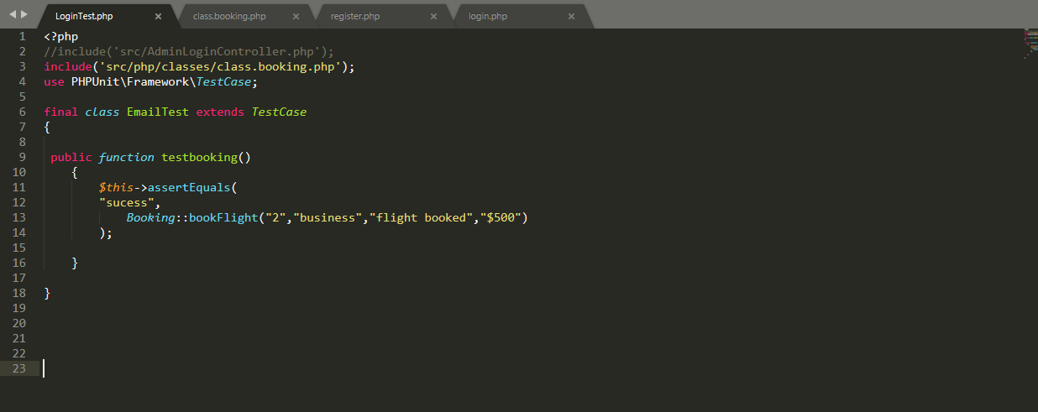

Fig: Code for booking success

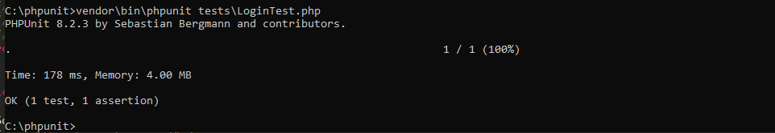

Fig: Message for booking success test

**Test name 4: Confirm booking test**

Pre-Condition: Should show message with no errors

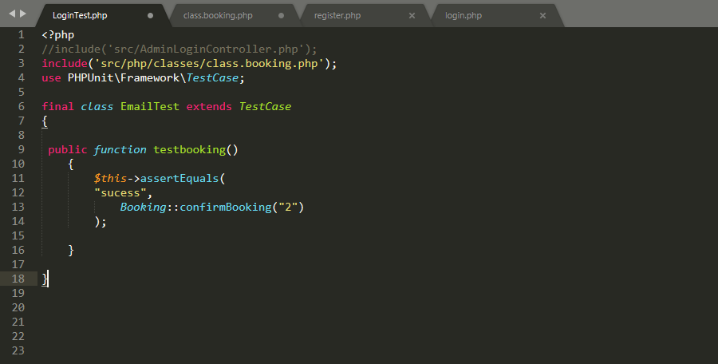

Fig: Code for confirm booking test

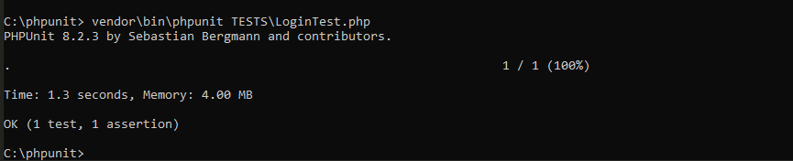

Fig: Message for confirm booking test

**Test name 5: Delete booking test**

Pre-Condition: Should show message with no errors

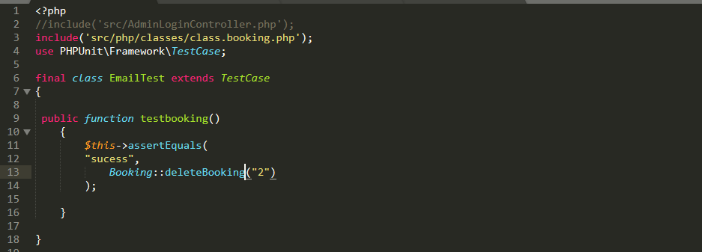

Fig: Code for delete booking test

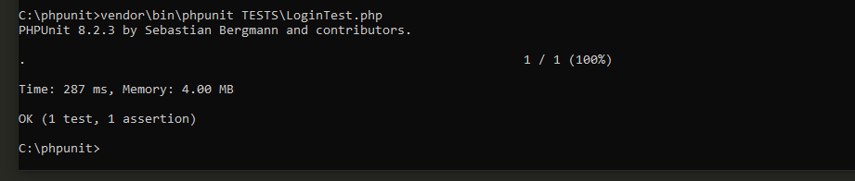

Fig: Message for test pass

# Chapter-6-Other Project Issues

Future Work

It is a part of works which will be done in future. The given project is of ticket booking which is a very sector so I was given very limited time for project accomplishment. Due to the time limitation for project I was not able to execute all the features which are mentioned in the project. Those features will be included during system update in future.

* Online payment system
* Adding comments and feedback
* Some security features
* Online response of queries
* Flights related other information’s

# User Manual

As the system developed will be completely new to the users. I have prepared a user manual so that clients or user can get all the instructions regarding the use of the system. It contains all basic things which are needed to use the system.

* **Registration**

User can register into the system from home page. They can only have access to login after they register inside the application.

1. Step-1 provide all the details needed for registration.
2. Step-2 Click on register button for registration.

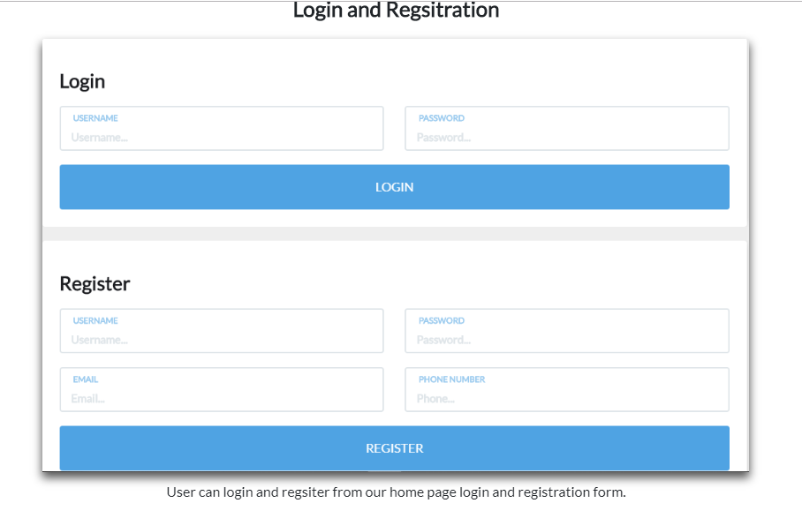

Provide all details

Click on register button

Fig: Registration from home page

* **Log-in**

User can login into the system directly from the home page of the system. First they need to register into the system after that they can login into system and have access to other activities like booking, viewing flight details etc.

1. Step-1 Provide username and password.
2. Step-2 Click on login button for having access.



Click on login button

Provide username and password

Fig: Login from dashboard

* **Flight Searching**

User can search flight and book them. After login into the system user can directly search flights.

1. Step-1 Provide all the details of flight.
2. Step-2 Click on search flight.

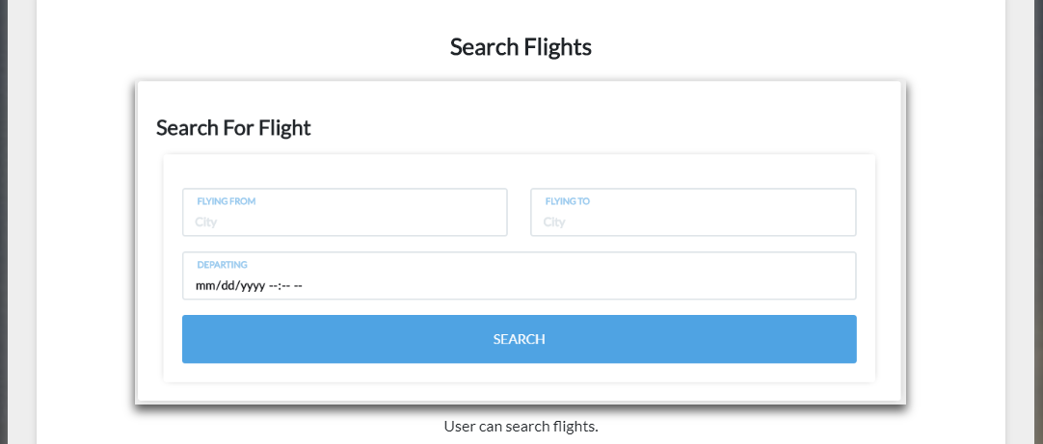

Provide all details

Click on search button

Fig: Searching for flights

* **Flight Booking**

After searching for particular flights, user can book flights by providing the related information. Payment is also compulsory for booking.

1. Step-1 Click on boot button after searching for flights

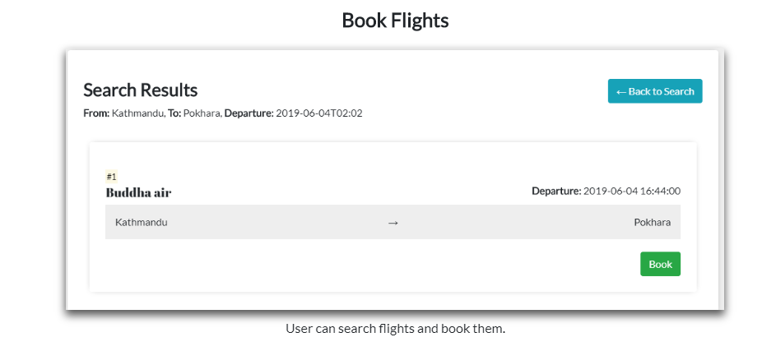

Click on book button after searching

Fig: Booking of flights

* **Profile Update**

The system allows for profile update. If user wants to update anything inside the profile, then they can put the relevant information and click on update button for update.

1. Step-1 Provides all the details to be updated.
2. Step-2 Click on new button after providing all details

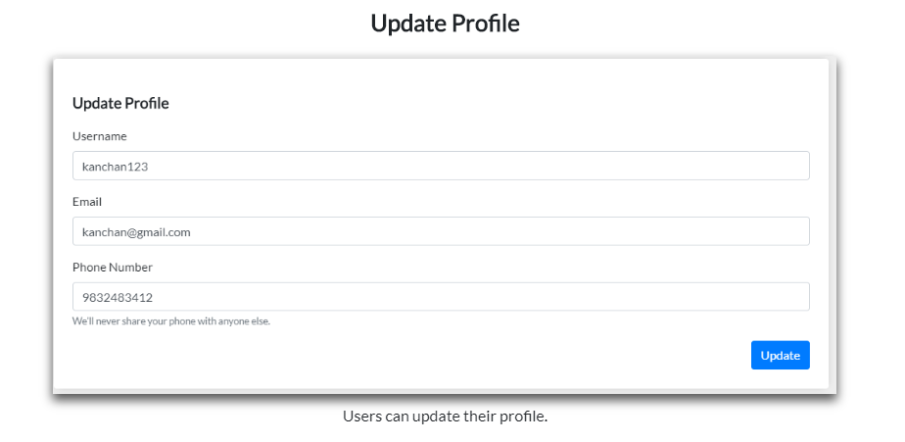

Click on update button

Provide all details to be update

Fig: Profile update of the customer

* **Update Password**

The system also allows for password update. If user finds if there is risk for the old password, then user can update new password for security.

1. Step-1 Provide old password
2. Step-2 Provide new password

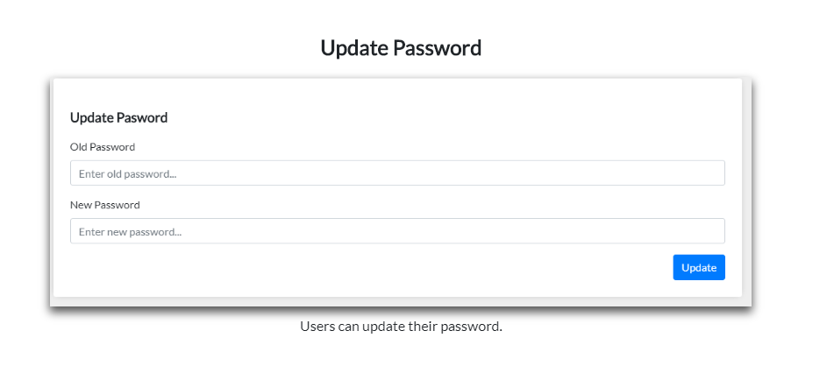

Provide new password

Provide old password

Fig: Password update of user

# Limitations of Project

Limitations of the project means the things that are enlisted in analysis or proposal but not implemented inside the system.

* There is not online payment system.
* User cannot get immediate response of their queries.
* Emailing is not currently working inside the system.

# **Chapter-7 Conclusion**

Online Air ticketing is a system which is web-based which allows customer for online ticket booking of respective airlines. It will provide 24 hours’ service to customer so that customer can book flights at anytime from anywhere. It will allow register customer to view flights details, price of flights, date and time of flights etc. Admin can edit information related to flights like adding flights, updating flights details and removing flights from the system. MVC design pattern is used to build system which will also play role of controller inside the application. For data base management MySQL is used and programming language used is core PHP. The only problems with the system is that it does not have online payment system.

# **Chapter-8-Appendix**

All the codes of the online air ticketing system are given below.

* Home page of system and its code

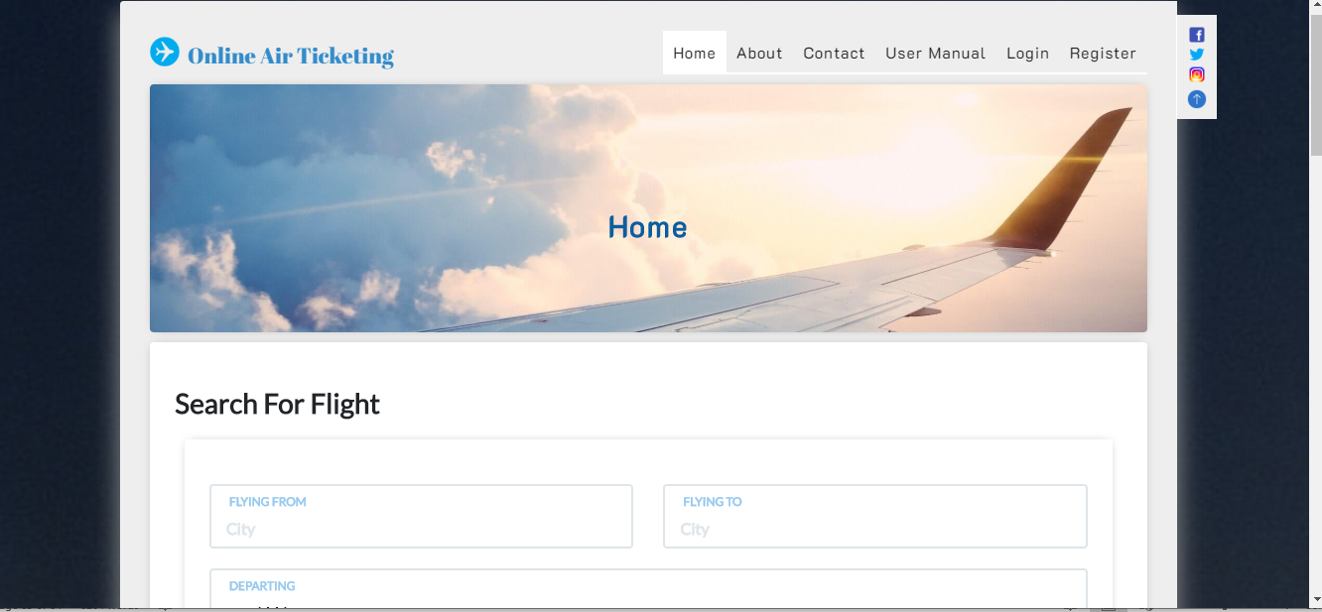

Fig: home page of system

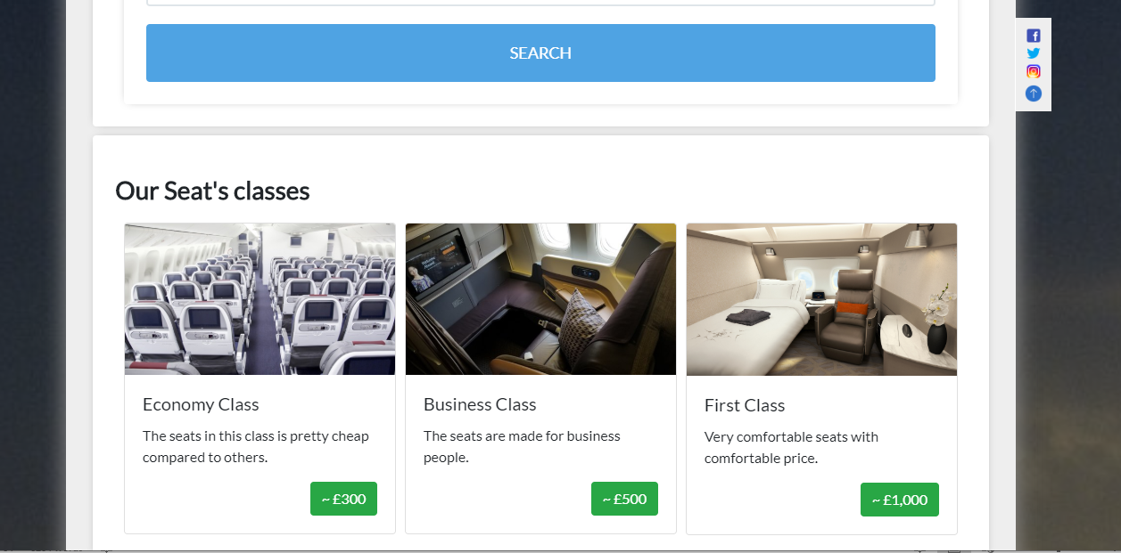

Fig: Home page of system

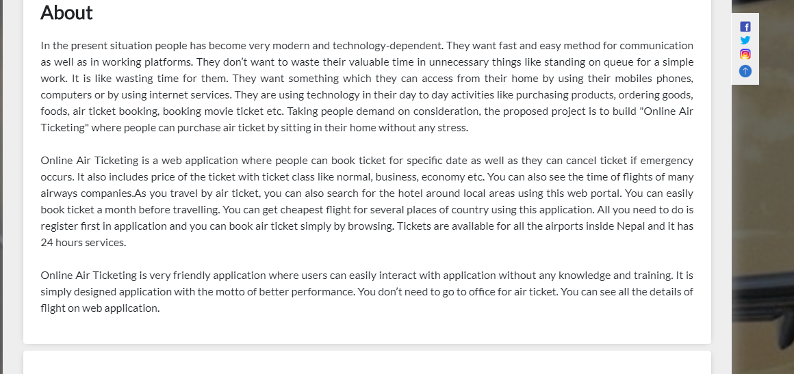

Fig: Home page of system

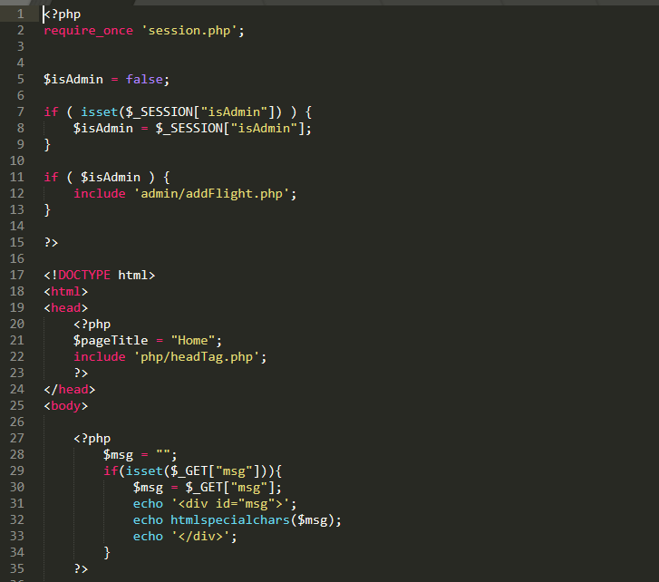

Fig: Code for home page

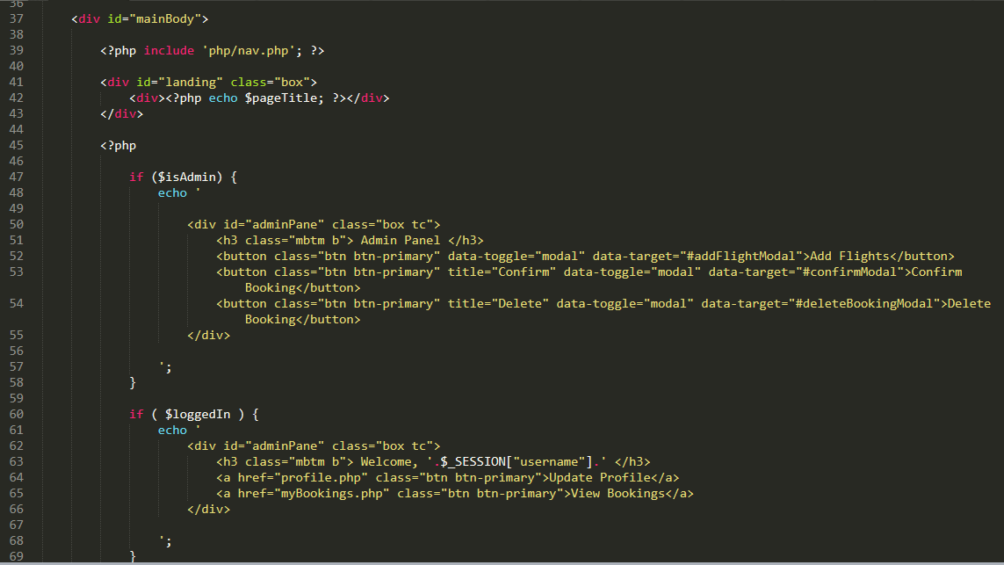

Fig: Code for home page

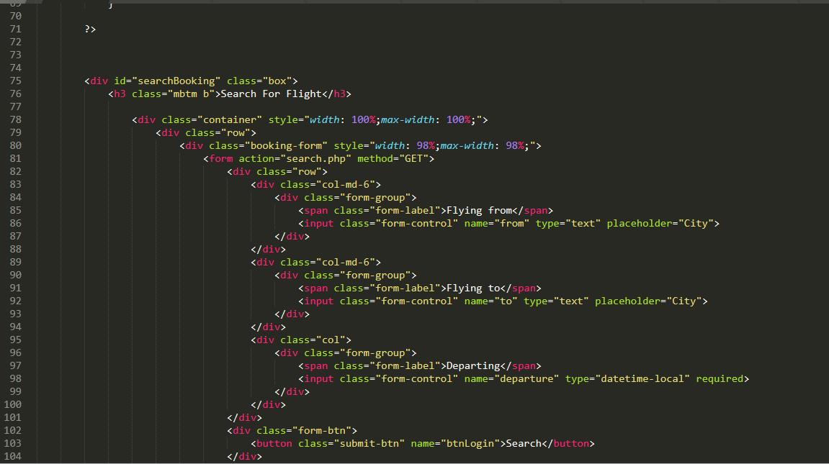

Fig: Code for home page

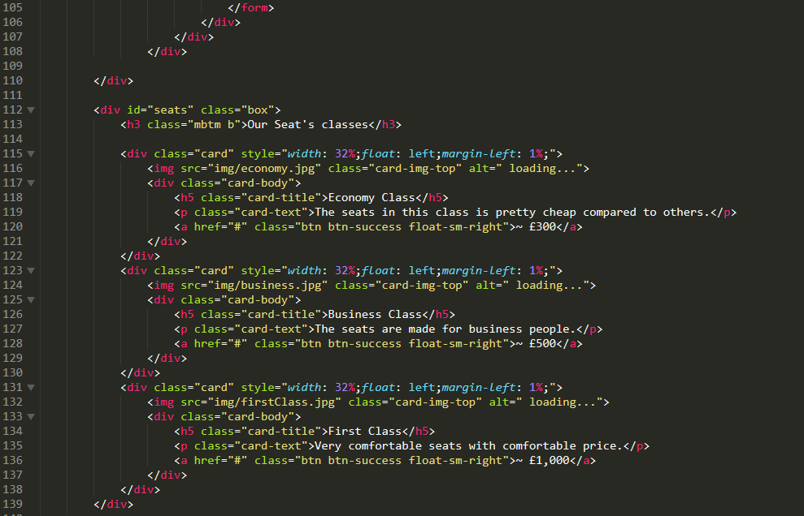

Fig: Code for home page

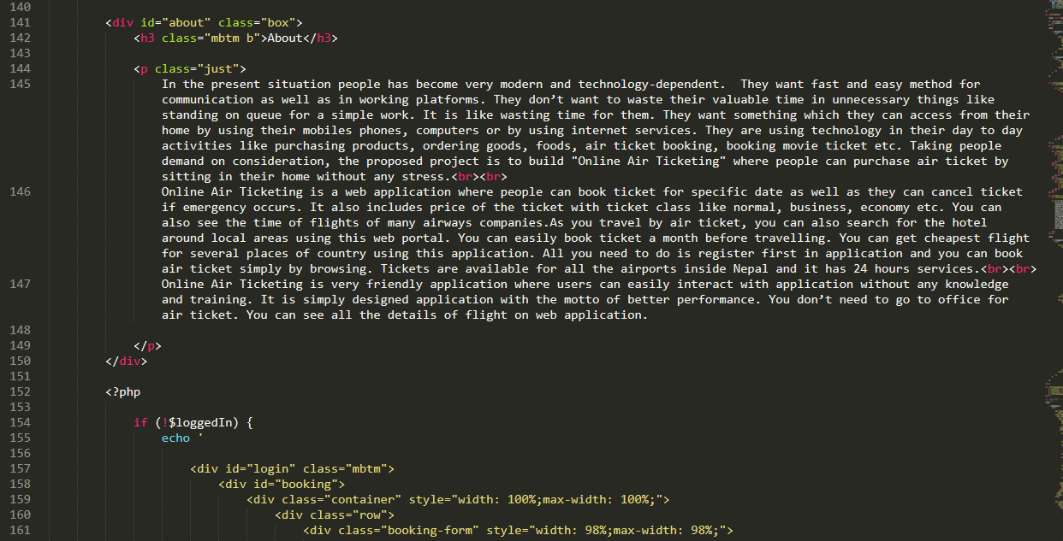

Fig: Code for home page

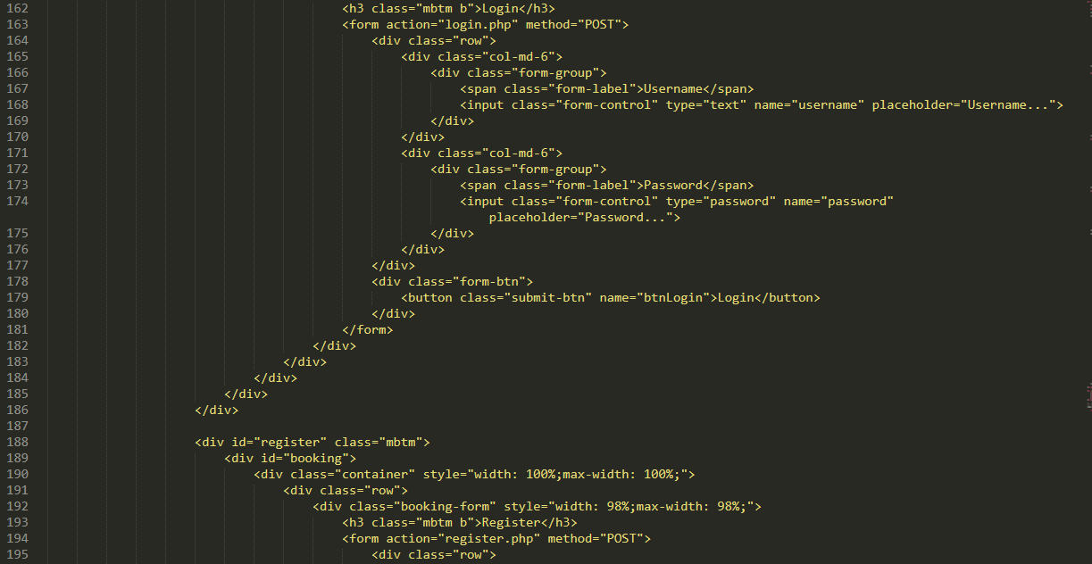

Fig: Code for home page

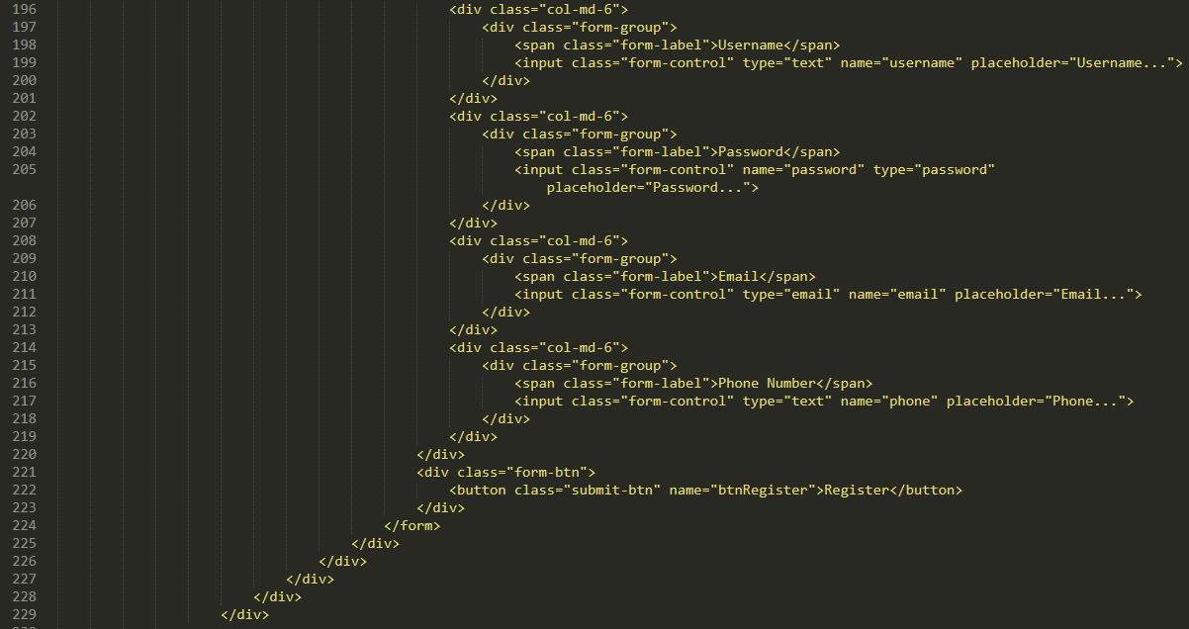

Fig: Code for home page

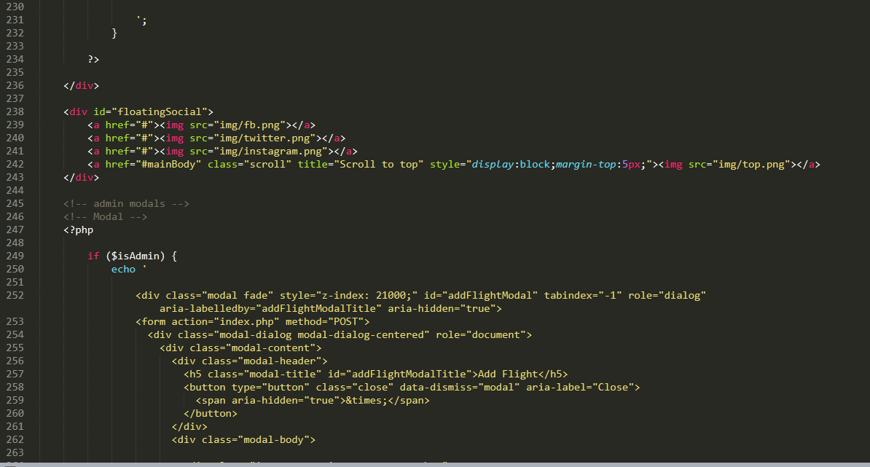

Fig: Code for home page

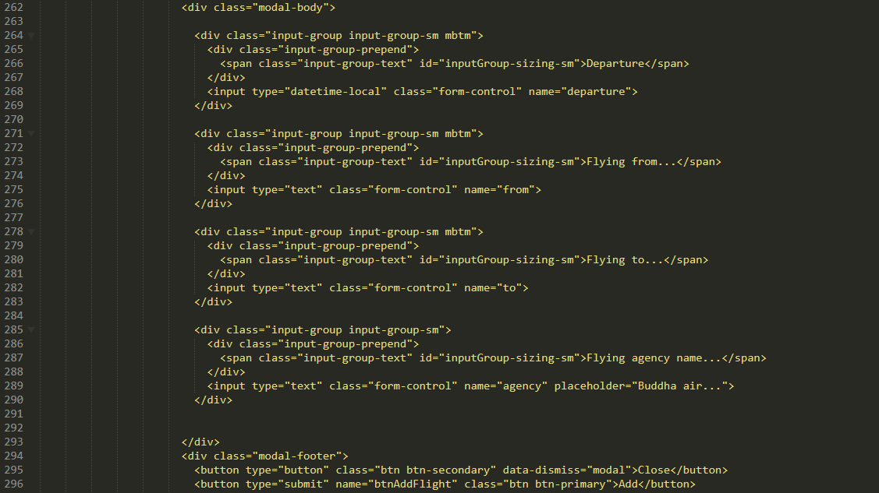

Fig: Code for home page

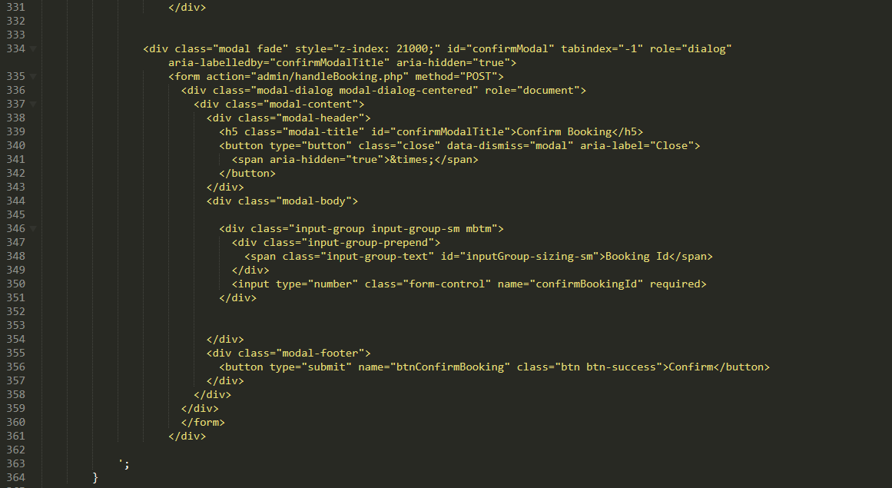

Fig: Code for home page



Fig: Code for home page

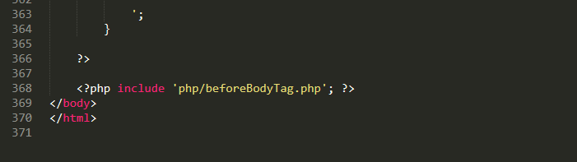

Fig: Code for home page

* Register page and its code

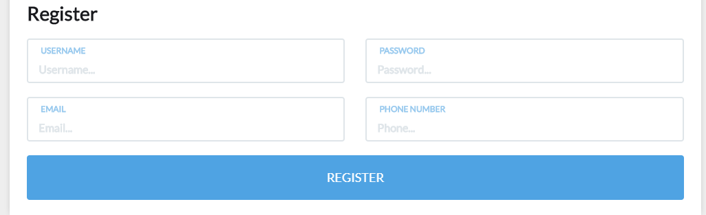

Fig: Register page

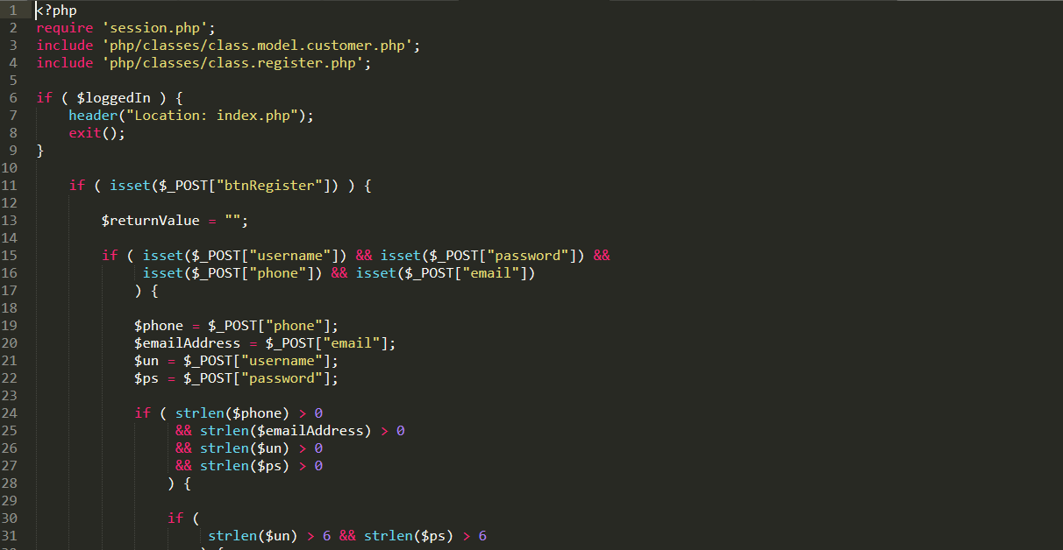

Fig: Code of register

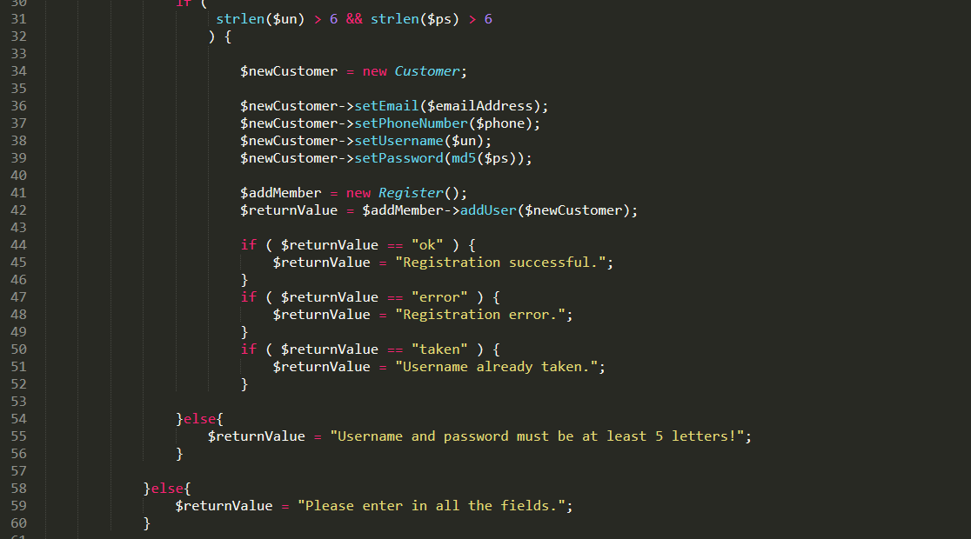

Fig: Codes of register

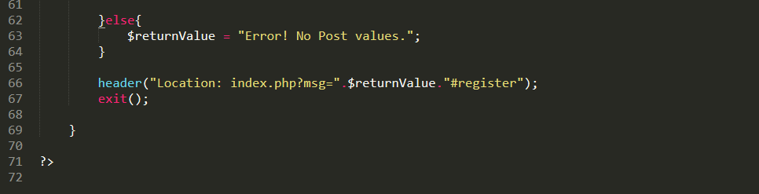

Fig: Codes of register

* Log in page and its code

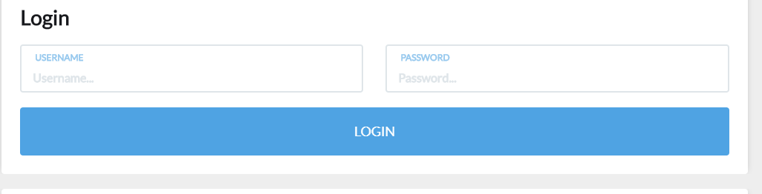

Fig: Log in page

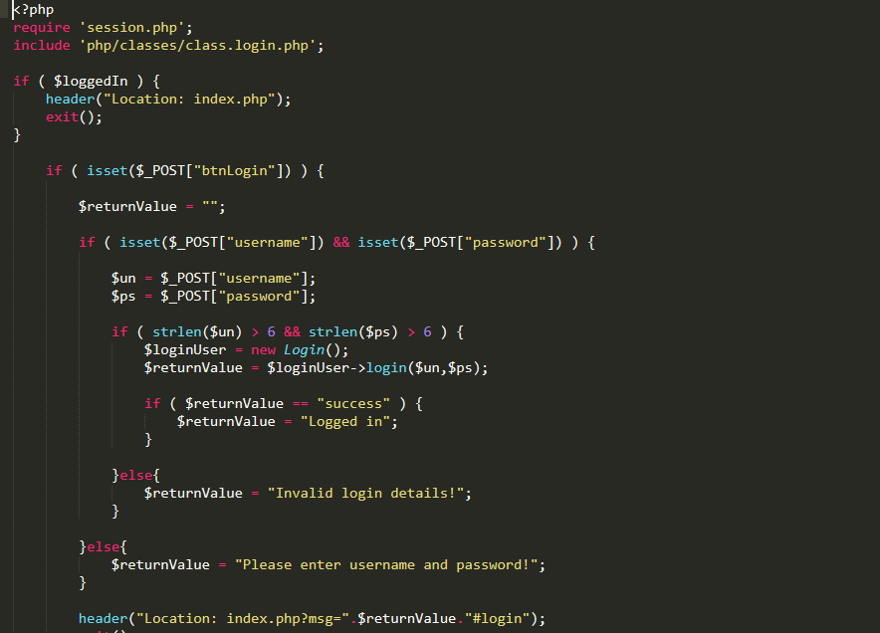

Fig: Code for login

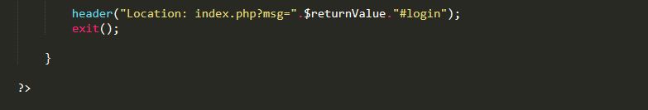

Fig: Codes for login

* Logout and its code

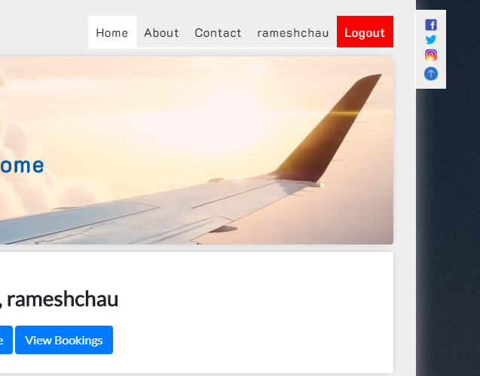

Fig: Log out page

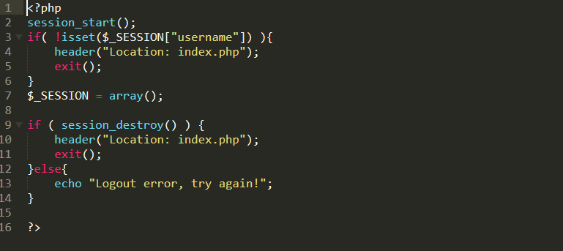

Fig: Codes for log out

* Searching and its code

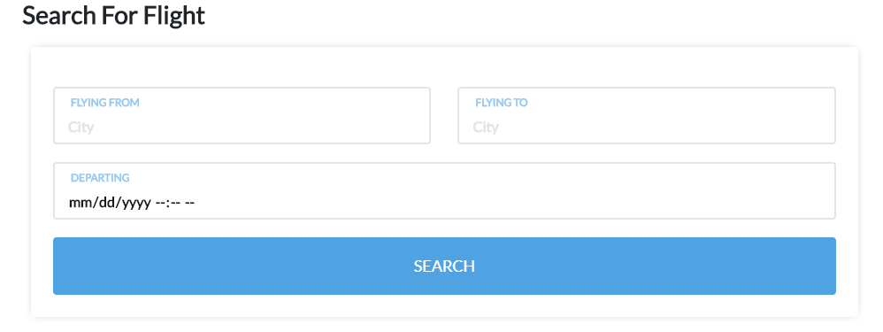

Fig: Search page

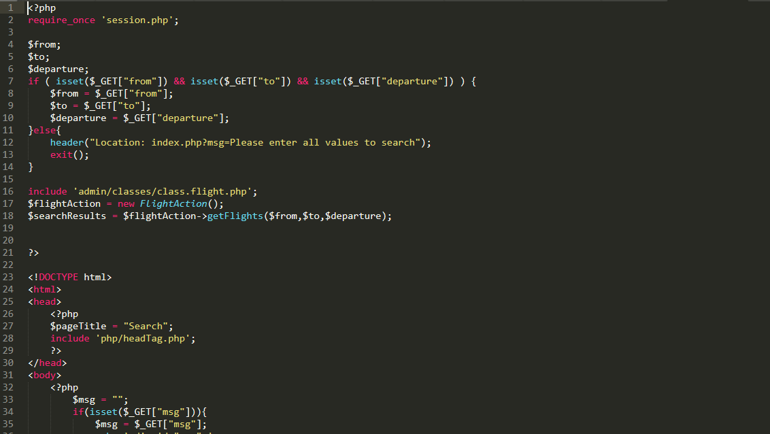

Fig: Code for search

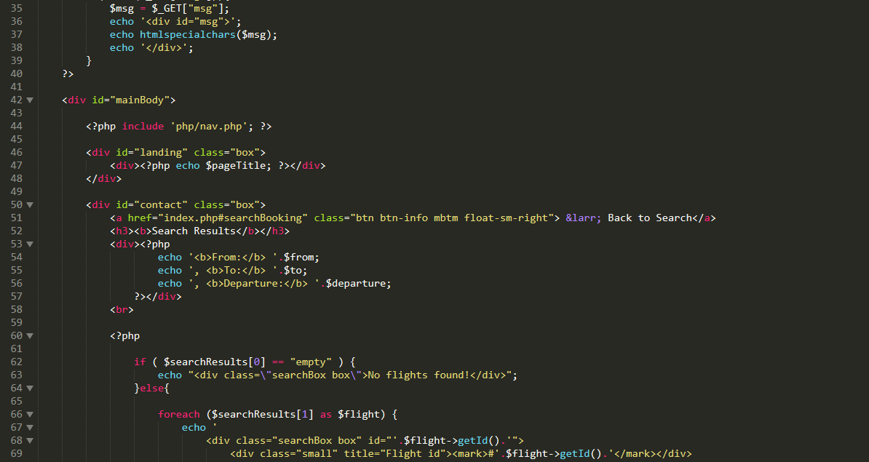

Fig: Code for search

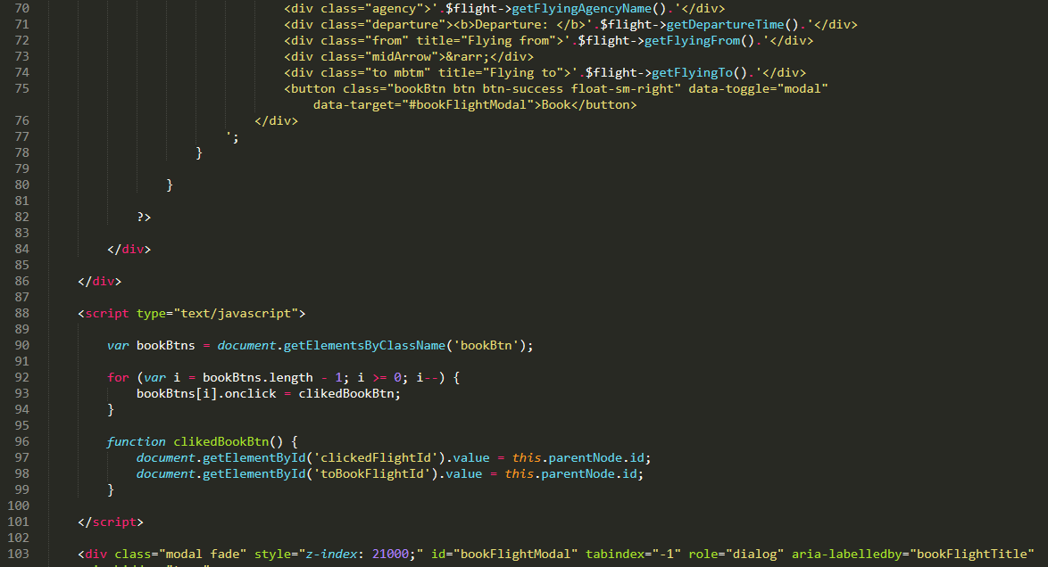

Fig: Code for search

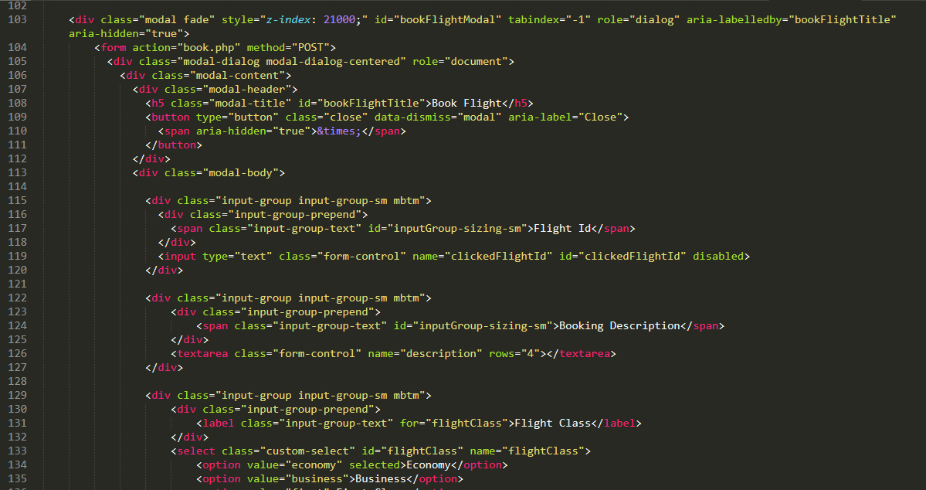

Fig: Code for search

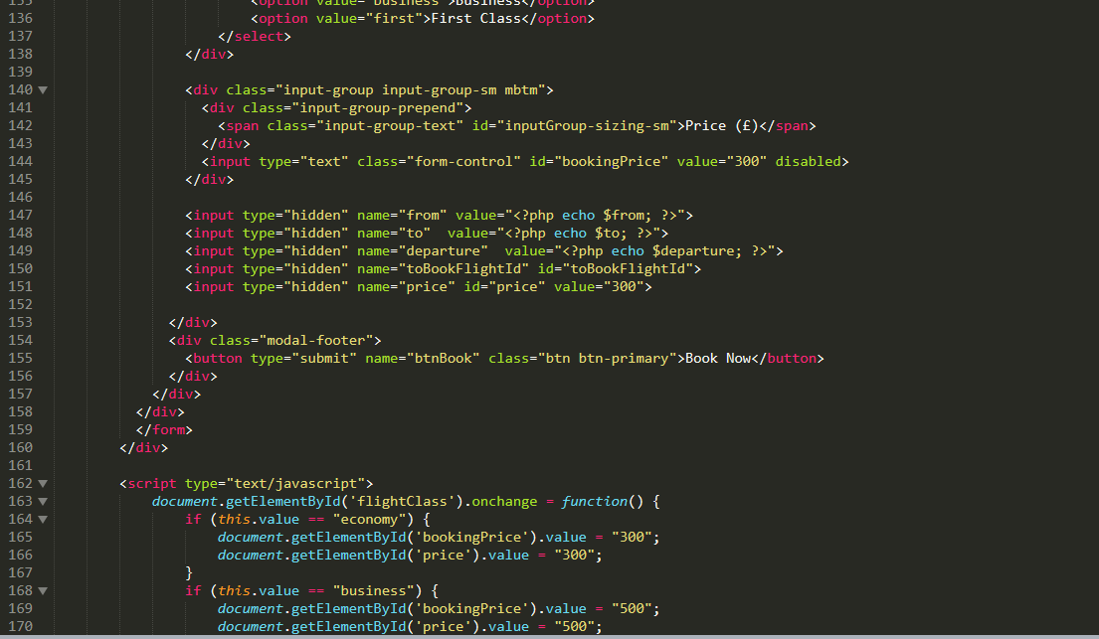

Fig: Code for search

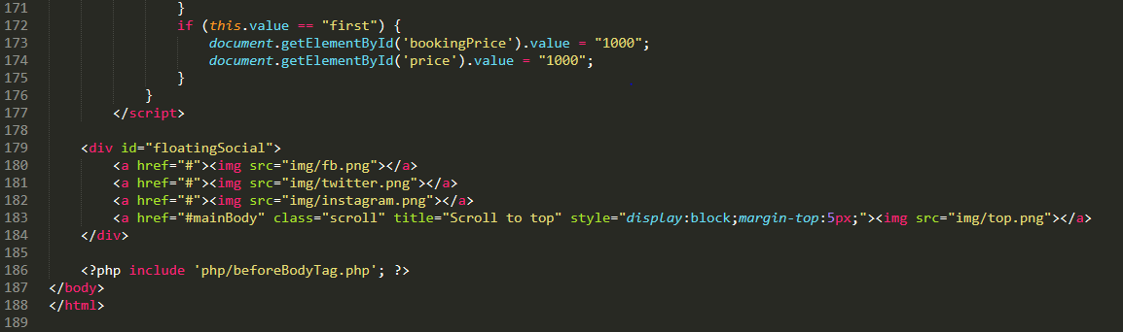

Fig: Code of search

* Profile and its code

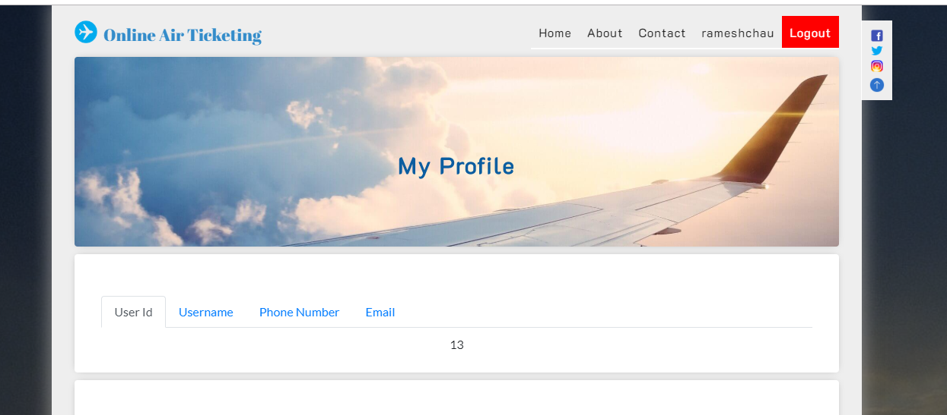

Fig: Profile page

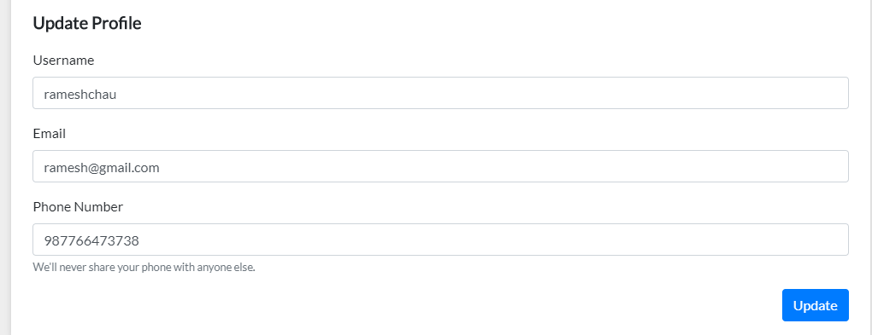

Fig: Profile page

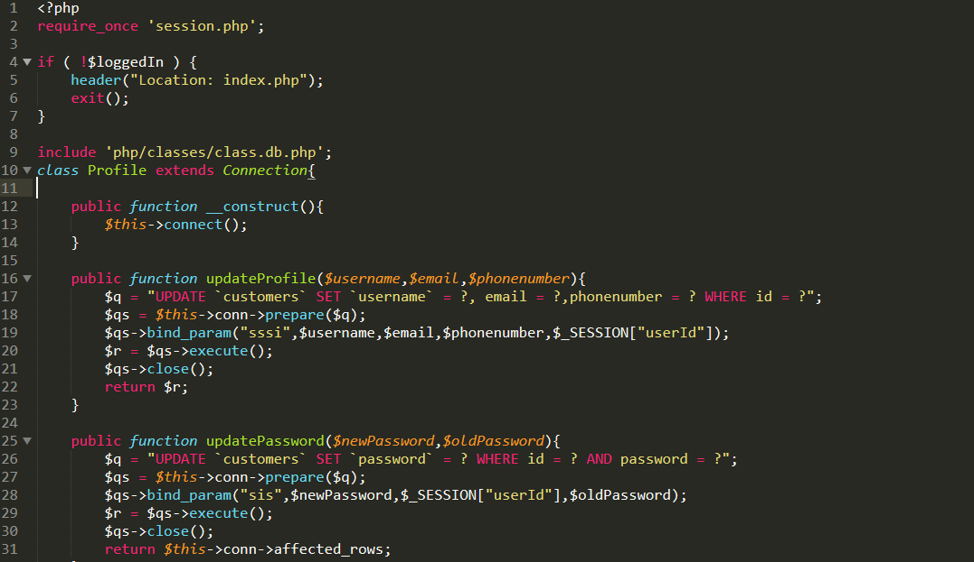

Fig: Code for profile

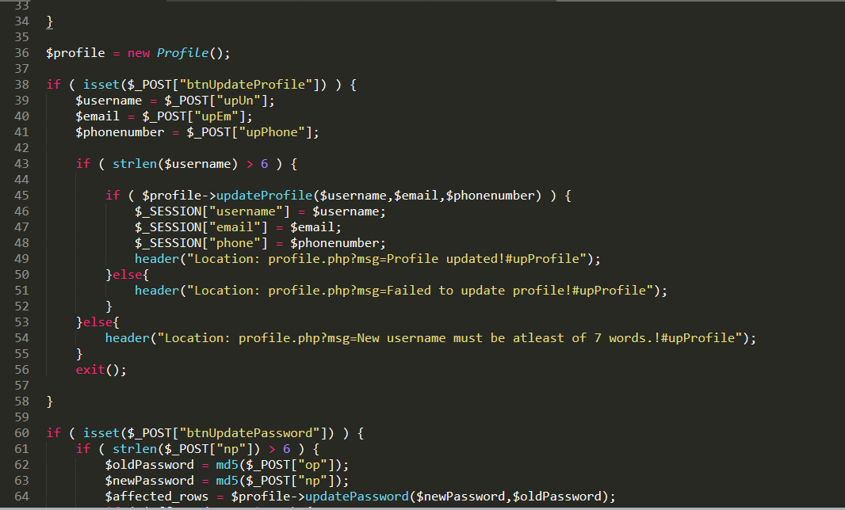

Fig: Code for profile

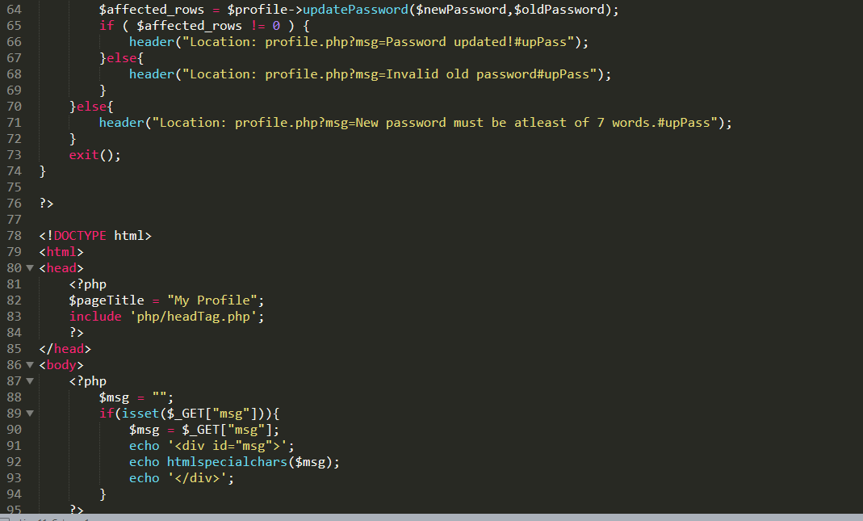

Fig: code for profile

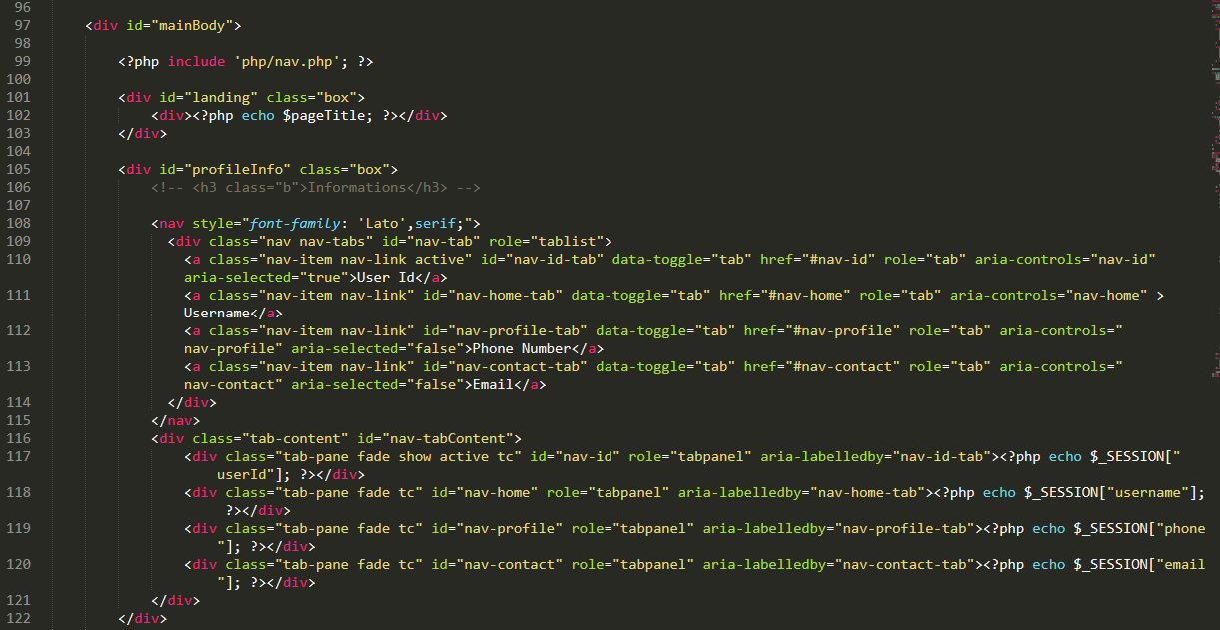

Fig: Code of profile

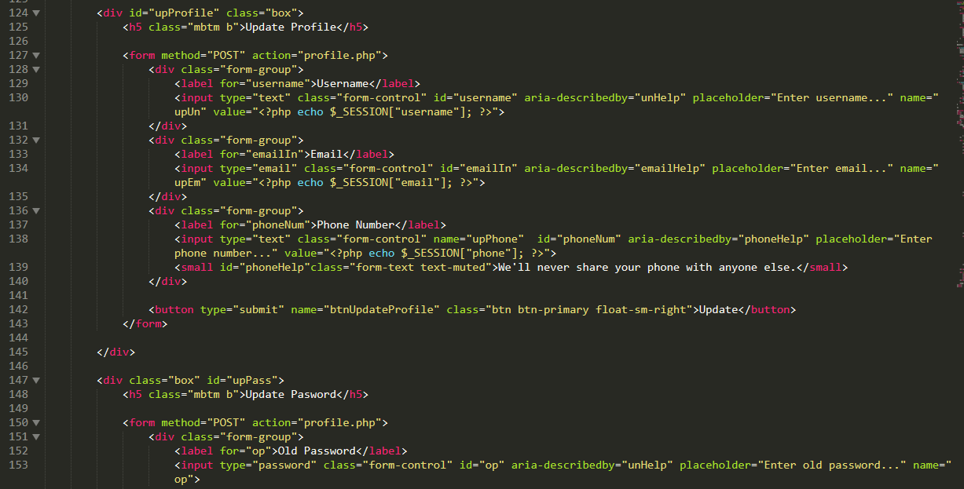

Fig: Code of profile

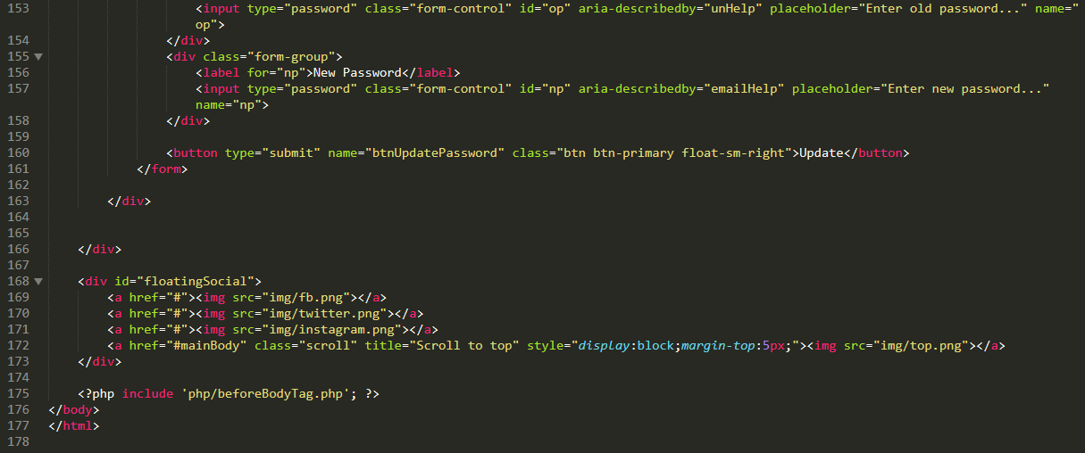

Fig: Code of profile

* User manual page and its code

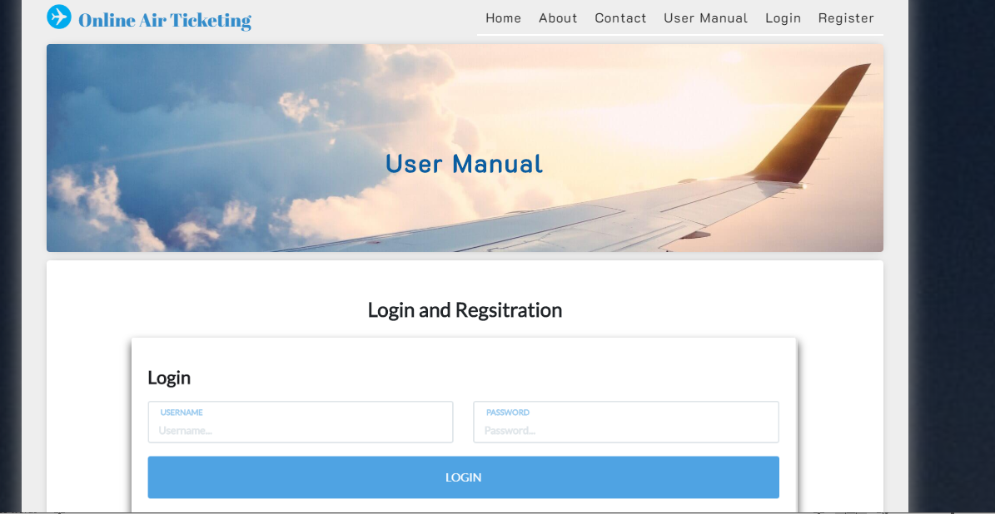

Fig: User manual page

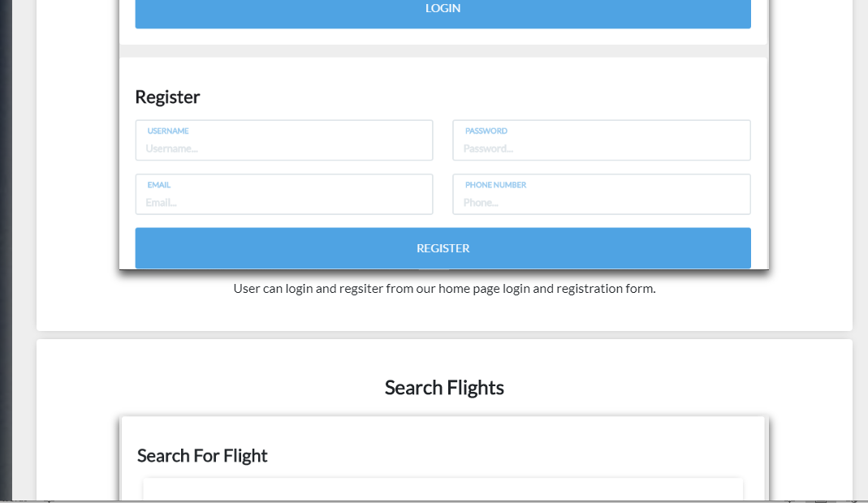

Fig: User manual page

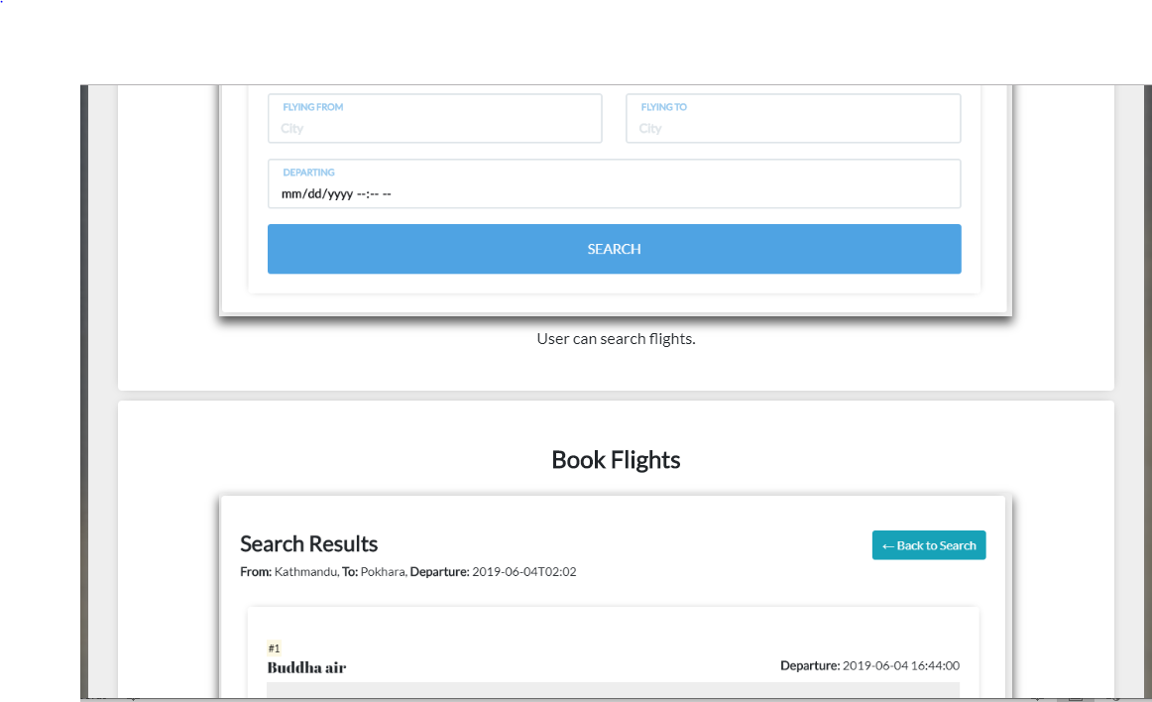

Fig: User manual page

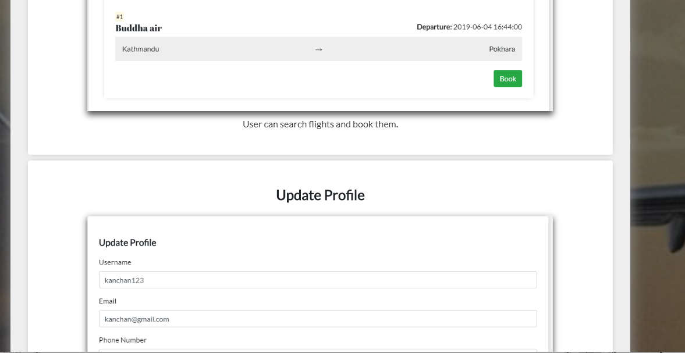

Fig: User manual

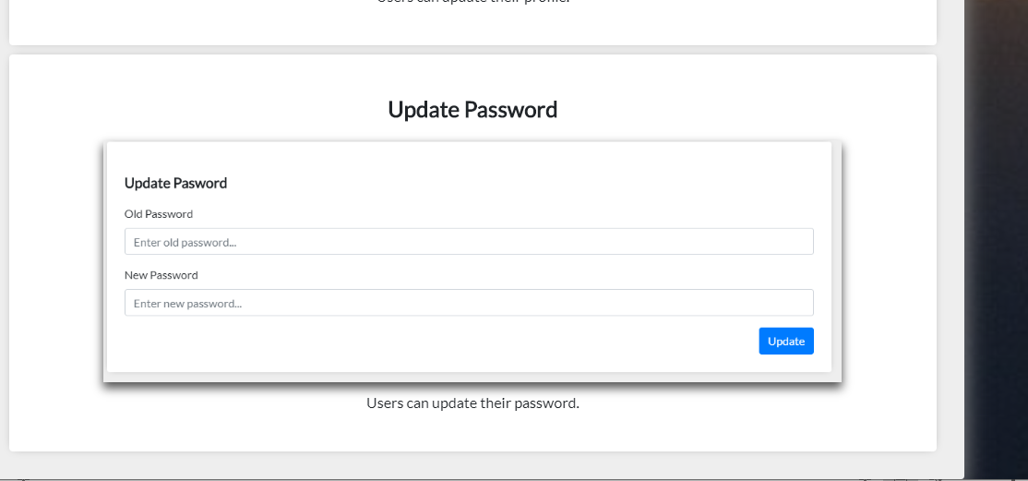

Fig: User manual

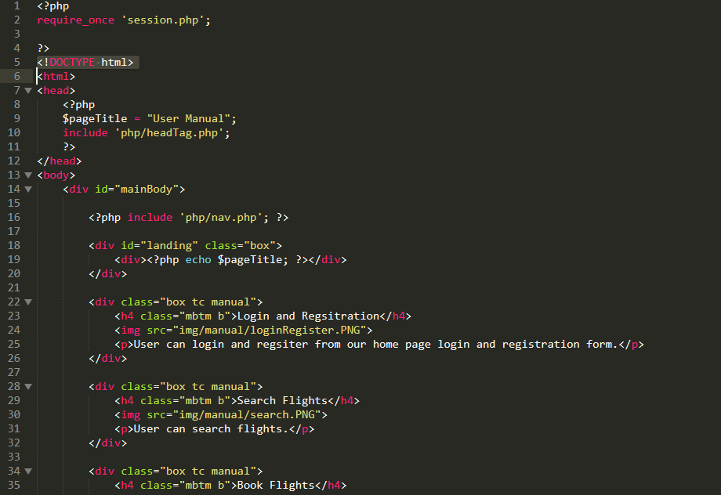

Fig: Code for user manual

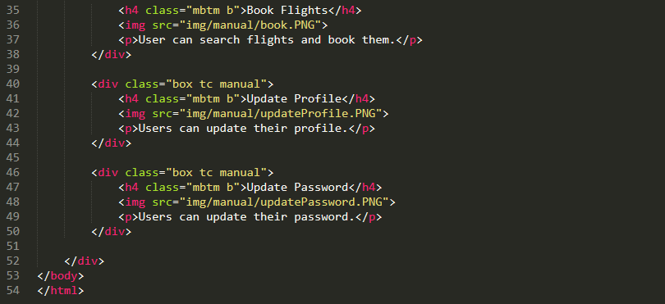

Fig: Code for user manual

* Admin panel page

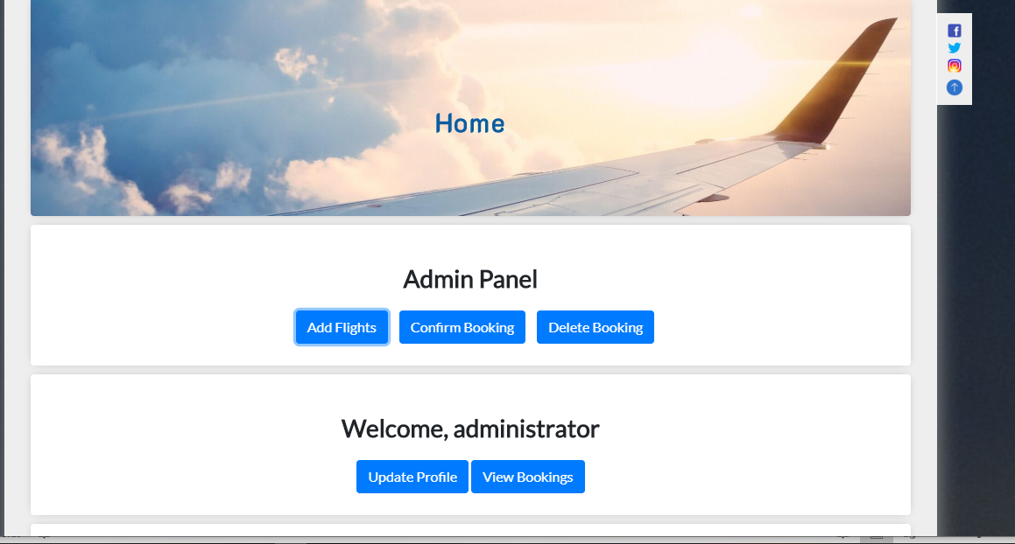

Fig: Admin panel page

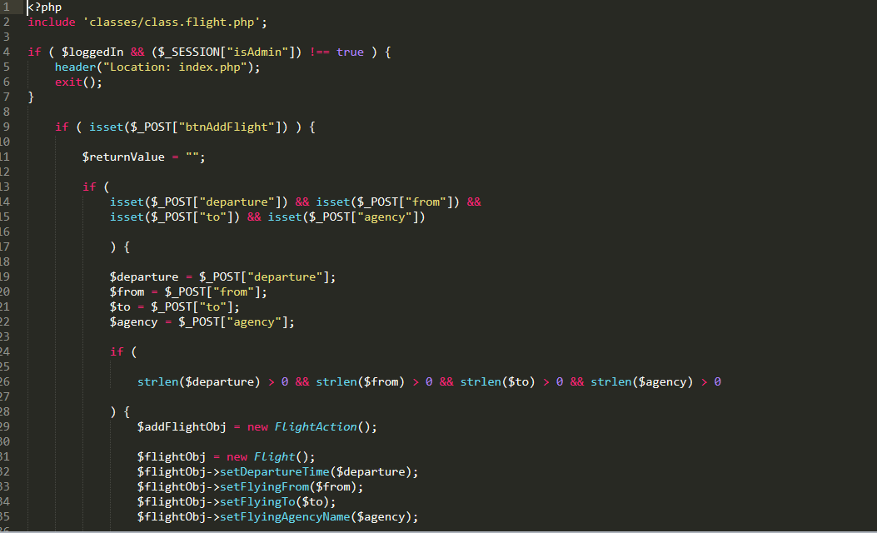

Fig: Code of add flight

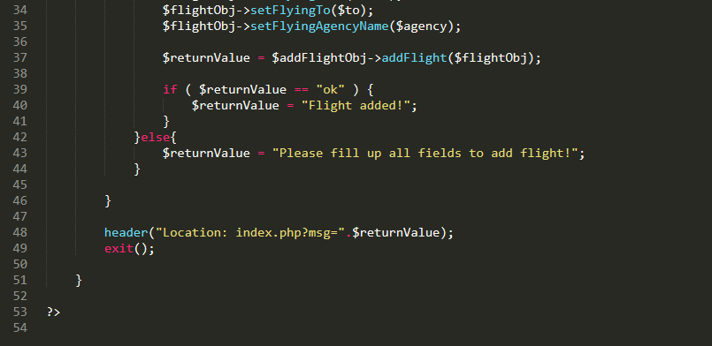

Fig: Code of add flight

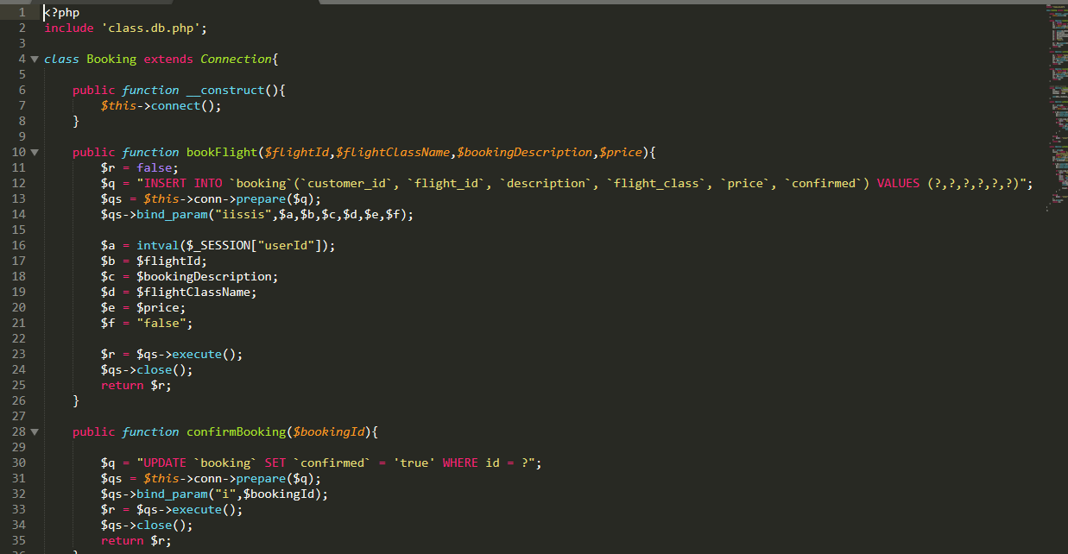

Fig: Code for booking

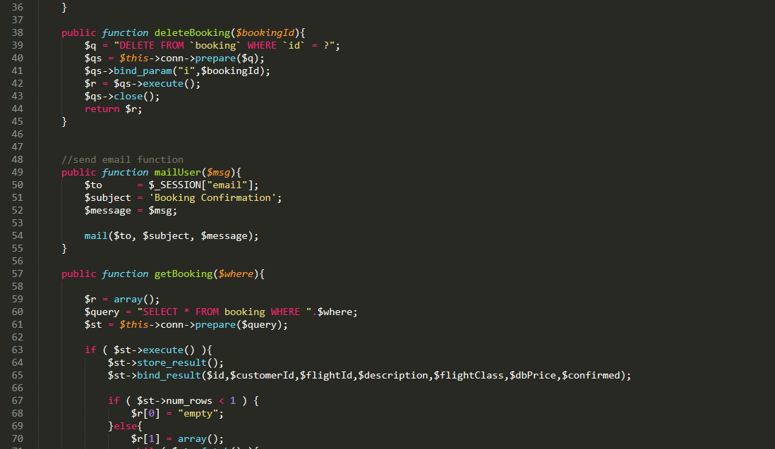

Fig: Code for delete booking

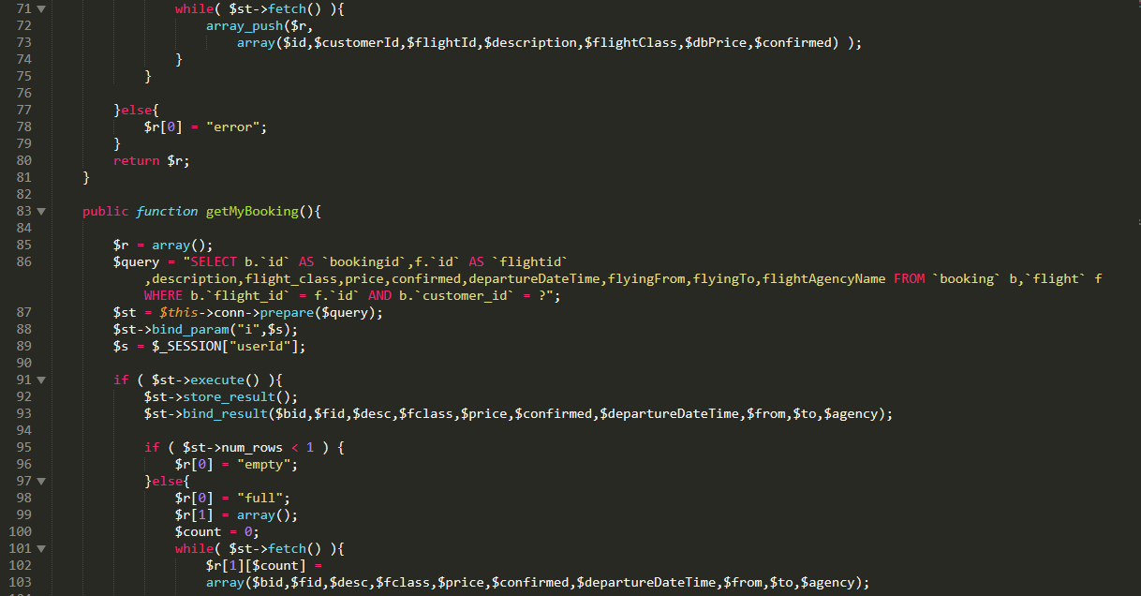

Fig: Code for booking

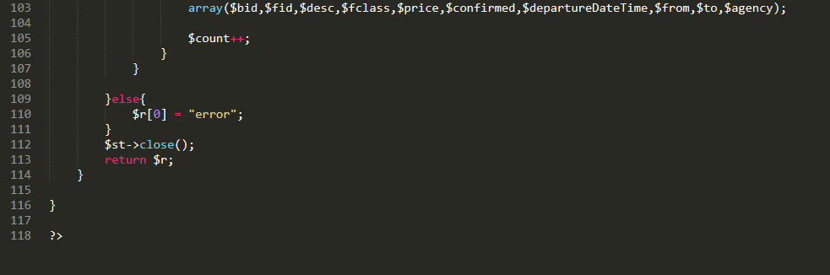

Fig: Code for booking

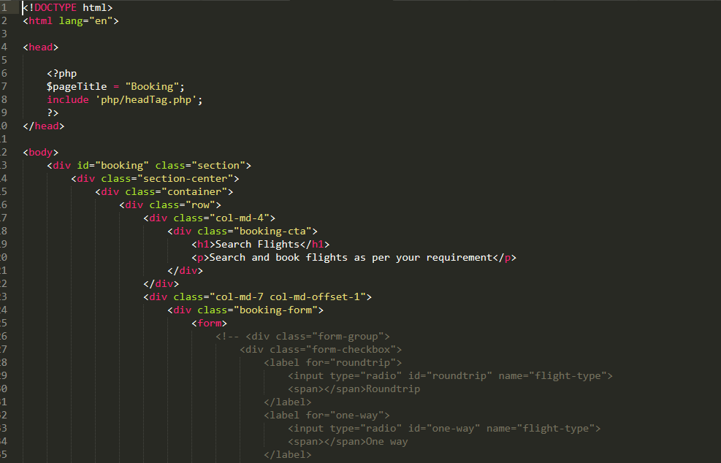

Fig: Code for booking

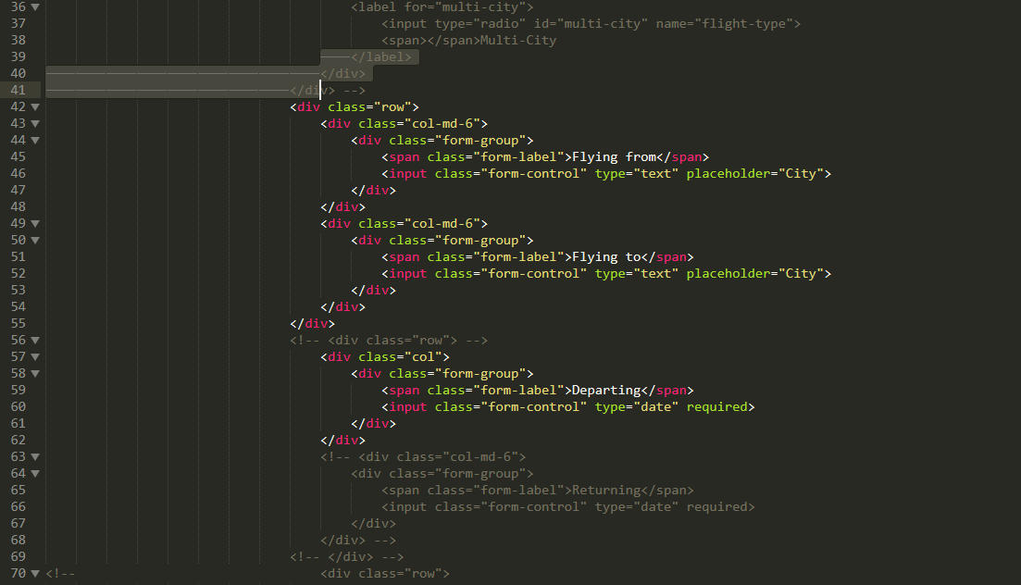

Fig: Code for booking

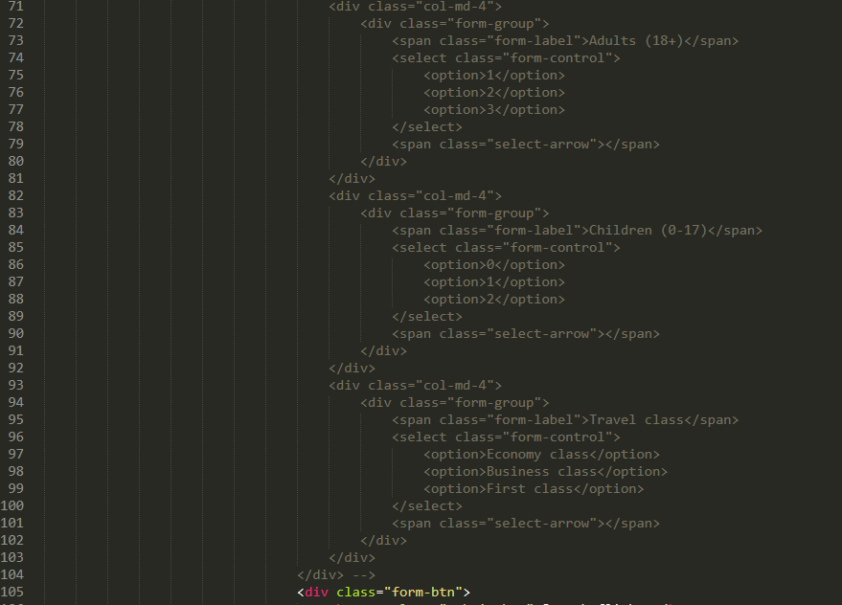

Fig: Code for booking

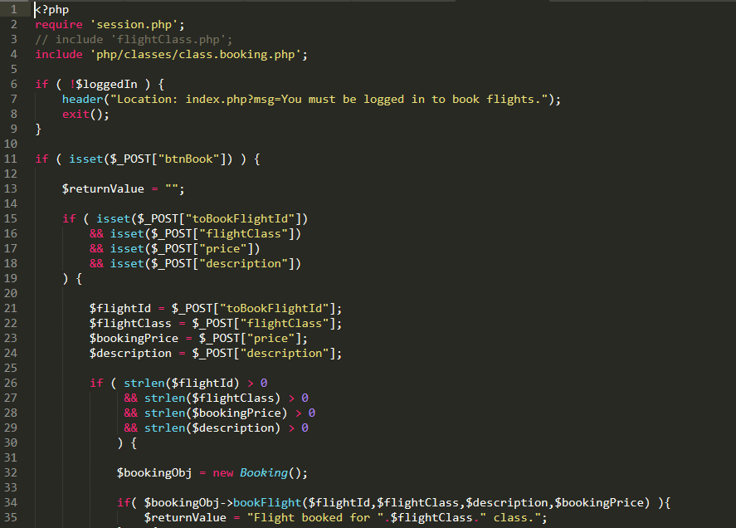

Fig: Code for booking

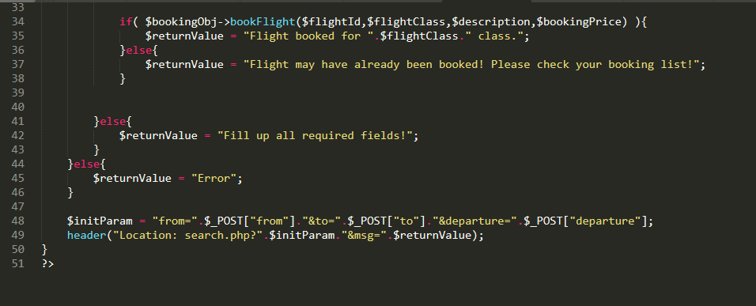

Fig: Code for booking

* Contact us page

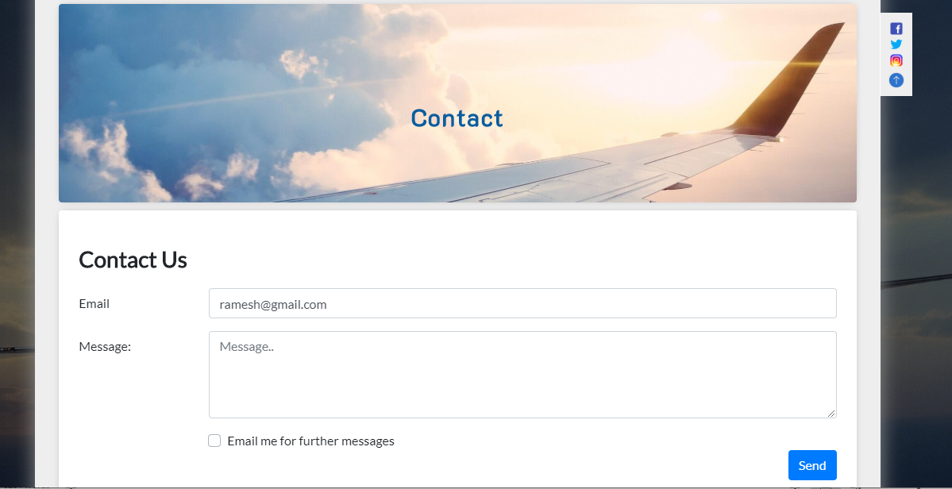

Fig: Code for booking

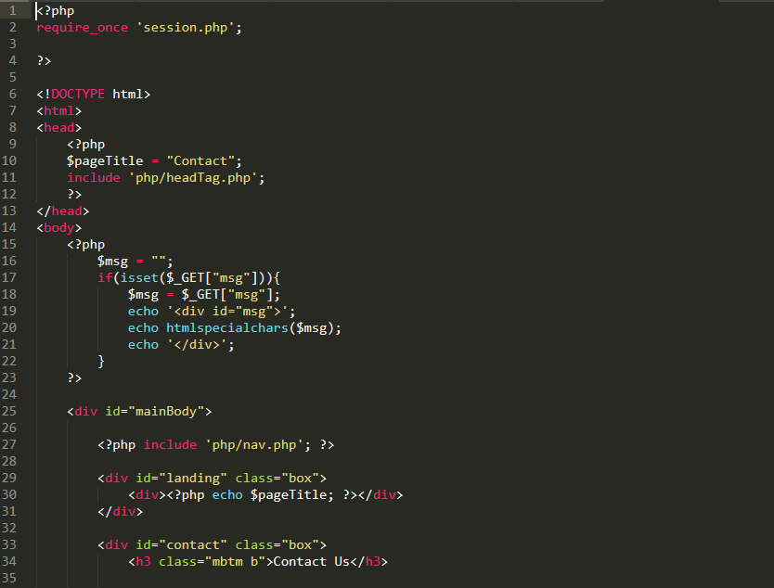

Fig: Code for contact us page

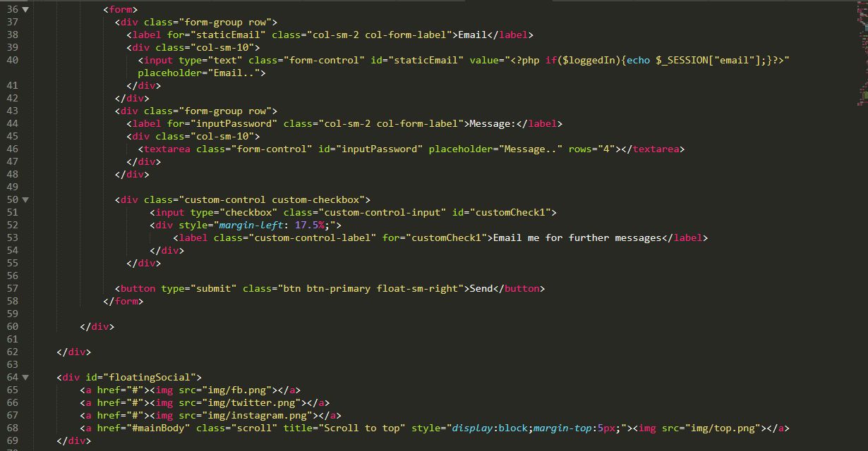

Fig: Code for contact us page

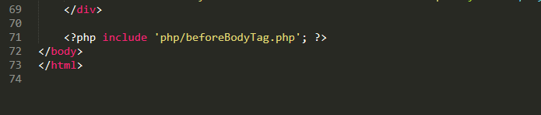

Fig: Code for contact us page

* Code for session

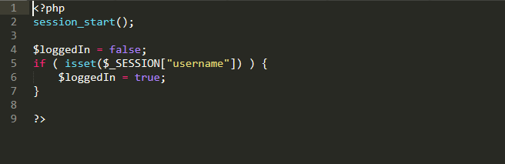

Fig: Code for session

* Codes for model of the system

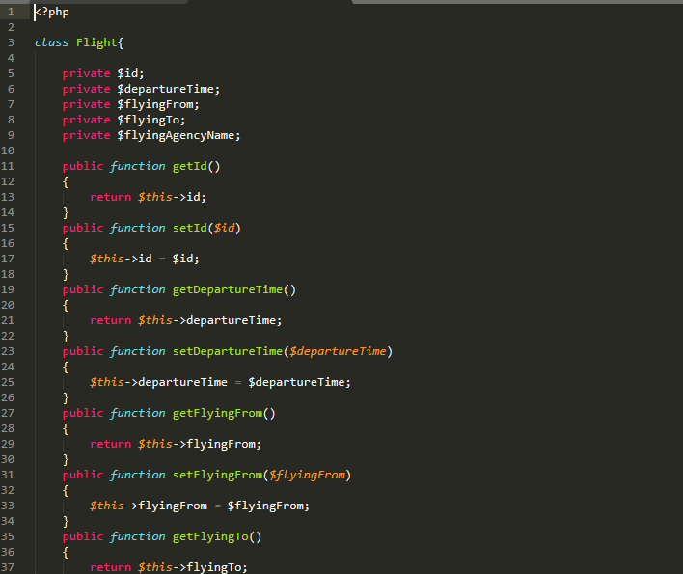

Fig: Code for model

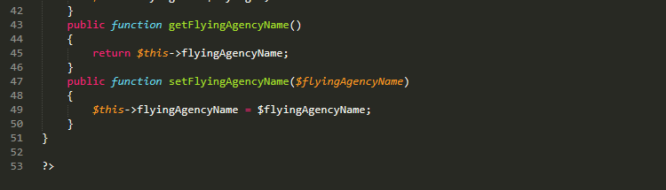

Fig: Code for model